Chapter 2. Getting Started

Read this section to get your DVR up and running. This section assumes that the DVR is already connected and cameras are attached. For more information, see the user manual supplied with the unit. Live footage can be viewed either on the local screen connected to the DVR or over a network if a connection exists.

2.1 Running modes
Images can be viewed on the screen attached to the DVR. You can control the number of images displayed on the screen and configure the DVR using either mouse control, or IR remote controller.

Note: The default startup mode for the DVR is mouse control mode. This can be changed by setting the Running Mode option as described later in this section.

Depending on how the DVR is configured, you will see images from the attached cameras on the screen. If the DVR is in mouse running mode, a graphical user interface (GUI) with clickable buttons will be displayed on screen as shown below. In this running mode, the IR remote control will not function. When the DVR is in IR remote control running mode, no GUI is displayed, only videos from the connected cameras.
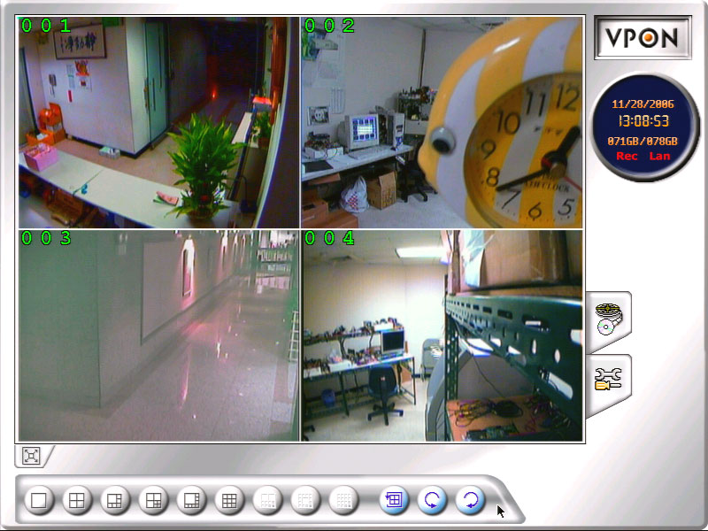

Follow these instructions to switch from mouse running mode to IR remote control running mode.
- Click the SET UP button on the GUI to display the setup menu.

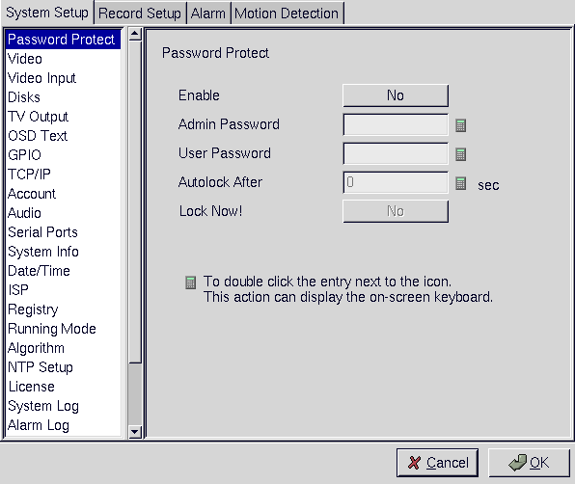

- From the list on the left of the screen, click the Running Mode heading to display the running mode menu.
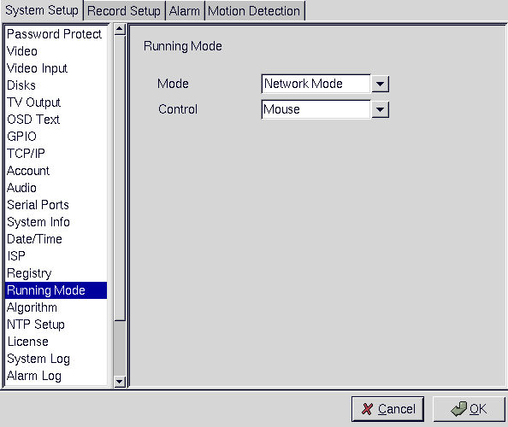

3. From the Control dropdown box, choose IR Control.
4. From the Mode dropdown box, choose either ISP mode if you are connected using an ISP type connection, or Network Mode, if you are connected to a network.
5. Click OK.
6. The system will automatically reboot in IR remote control mode.

Follow these instructions to switch from IR remote control running mode to mouse running mode.
1. Press the Menu button on the remote control to display the setup menu on screen.

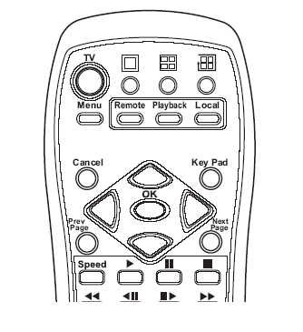
Menu button

2. Use the up and down arrow buttons to highlight the Running Mode option and press the OK button to confirm your choice. The running mode menu will be displayed on screen.

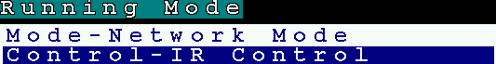

3. Use the up and down arrow buttons to highlight the Control – IR Control field.
4. Use the left and right arrow buttons to toggle between Control – IR and Control – mouse.
5. Press the OK button when the control field is set to mouse.
6. The unit will reboot when the OK button is pressed. It will restart in mouse running mode.

