Chapter 1. VP-101 Introduction

VP-101 is a High performance Plug and Play DVR Kit based on Network DVR on Chip and MPEG4 Hardware CODEC technology. There is no additional operating system installation required to build the network DVR system. VP-101 can do 4 channels Real-Time CIF (360x240) MPEG4 Audio / Video recording / Playback simultaneously. It is completely plug & play to easily get you up and running.

1.1 Specifications:

Model | VP-101
Video Input | Support NTSC/PAL composite video  4 BNC video input connectors
Audio Input | 4 audios input
VGA Output | 24 bit true color
Sensor Input/ Relay Output (Optional) | 4 input / 4 output
Compression Standard | MPEG4 Hardware CODEC
Image Resolution | 24bits 360x240(Default) , 720x480
Maximum Live Display Frame Rate | 30 fps / Channel, 480fps / Total (NTSC)  25 fps / Channel, 400fps / Total (PAL)
Maximum Video Recording Frame Rate(Total) | 480fps/ CIF , 120fps/ Full D1 (NTSC)  400fps/ CIF , 100fps/ Full D1 (PAL)
Minimum System Requirement | Pentium IV 2.0GHz CPU or better  512MB DRAM,  One IDE slot for DOM Chip  AGP VGA card
Browser Compatibility | Win 98/2000/XP running MS Internet Explorer 6.0 or later
Communication Protocol | Support Mini-Firewall, TCP/IP , PPPoE , DHCP , NTP , HTTP , FTP , Multicast , UPNP
Backup Function | IDE or USB Interface HDD, CD-RW, DVD+RW
Language | English, Traditional Chinese, can be localized to other language
Safety | FCC, CE
Standard Package | DOM with VPON Firmware  VP-41 Capture Card  User Manual

1.2 System Requirements

Composite CCD camera, V8 or camcorder… (NTSC or PAL standard)

The equipment for connecting to network:
- Network mode: RJ-45 Ethernet network port connected to Internet and a public IP address
- Others: RS-232 Port and a serial cable for connecting to host PC.
- A VGA or TV monitor for display.

PC for installing VP-101
NOT EVERY PC PLATFORM CAN BE USED FOR VP-101 INSTALLTION. PLEASE REFER TO MOTHER BOARD SUPPORTING LIST IN APPENDIX.

PC for the configuration / browsing
1. Pentium 4 CPU or better, desktop PC or notebook
2. 128 MB RAM or above
3.AGP VGA Card
4. Microsoft Windows 98/2000/ME/XP or above
5. Internet Browser (such as Microsoft Internet Explorer 6.0 or above)

1.3 Summary of the installing

Before install VP-101 to your PC platform, please make sure the PC’s Hardware is compatible with the motherboards, which we have recommended in the appendix.

VP-101 contains:
Description | Quantity
VP-41 Vide Capture Card | 1
DVR on chip module (DOM) | 1
IrDA Controller & receiver | 1
Manual CD | 1
Hardware user manual | 1
Yellow IDE Cable | 1
Watch dog Wire | 1
Audio input cable | 1
Audio cable | 1
Battery | 2

1.4 Installation

Step 1 : Installing Motherboard
We recommend motherboards that support Linux device drivers. If you purchased a non-recommended motherboard yourself make sure it works. We are not responsible for non-approved motherboards. We carry recommended motherboards for system integrators to use. Put the motherboard together just like a regular PC.

Step 2: Installing CPU
We recommend any Pentium 4 Class CPU. Install as usual and attach the heat sink and fan.

Step 3: Installing Memory
We recommend installing two good brand name 256MB DDR memories. If you have up to 2 VP-41 (video capture cards), we strong recommend you using 512MB DDR memory for getting better system performance.

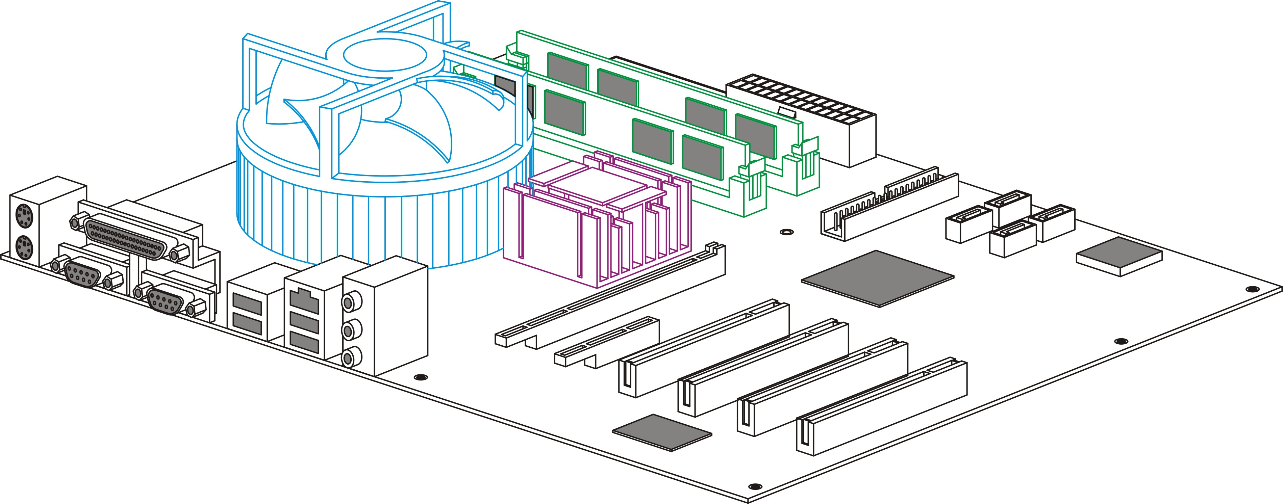
DDR Memory

Step 4 : Installing Video Card
We recommend video cards as in supporting list (Please check appendix) .We carry video cards for system integrators. Insert the video card into the AGP slot. Not all video cards will work due to unsupported Linux device drivers.

Step 5: Installing VP-41 Video Capture Card
Our video capture card is proprietary and will only work with our DVR chip. Install the video capture card into an available PCI slot. Once the system boots the DVR firmware will automatically detect how many video capture cards are in the PCI slots.
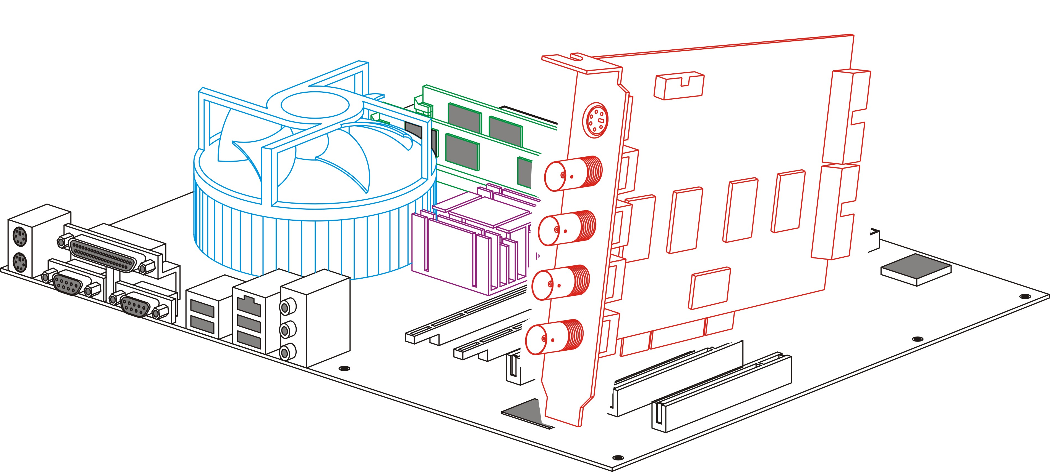
VP-41 Video Capture card

Step 6: Installing the hard drives
For a single drive make sure the jumper settings is set on primary. Attach that with any ordinary IDE cable onto the secondary IDE channel.
For dual drives make sure one hard drive is set on primary and the secondary on slave. Attach those to the IDE cable and plug into the secondary IDE channel.
The max hard drive size supported is 250GB each. For a total of 500GB.
Note: When VP-101 is working at the first time, VP-101 will erase the data in the hard disk. If there is important information in the hard disk, please remember to backup the data in another storage.

Step 7: Installing the VP-101 DVR module
The VP-101 DVR module sits on the primary IDE slot on the motherboard. If attaching a CD-RW to your unit then put the VP-101 DVR module in the middle of the yellow IDE cable included. And then put the end of the yellow IDE cable to the CD-RW and the other end to the primary IDE channel. The yellow IDE cable must be used with the VP-101 DVR module and not any generic IDE cable. Then attach the power connector from the VP-101 DVR module to a free lead from the power supply.
Note: Users must plug “Master” connector of the VP-101 power cable to the 4-pin plug of the power supply. Otherwise, VP-101 may not work!

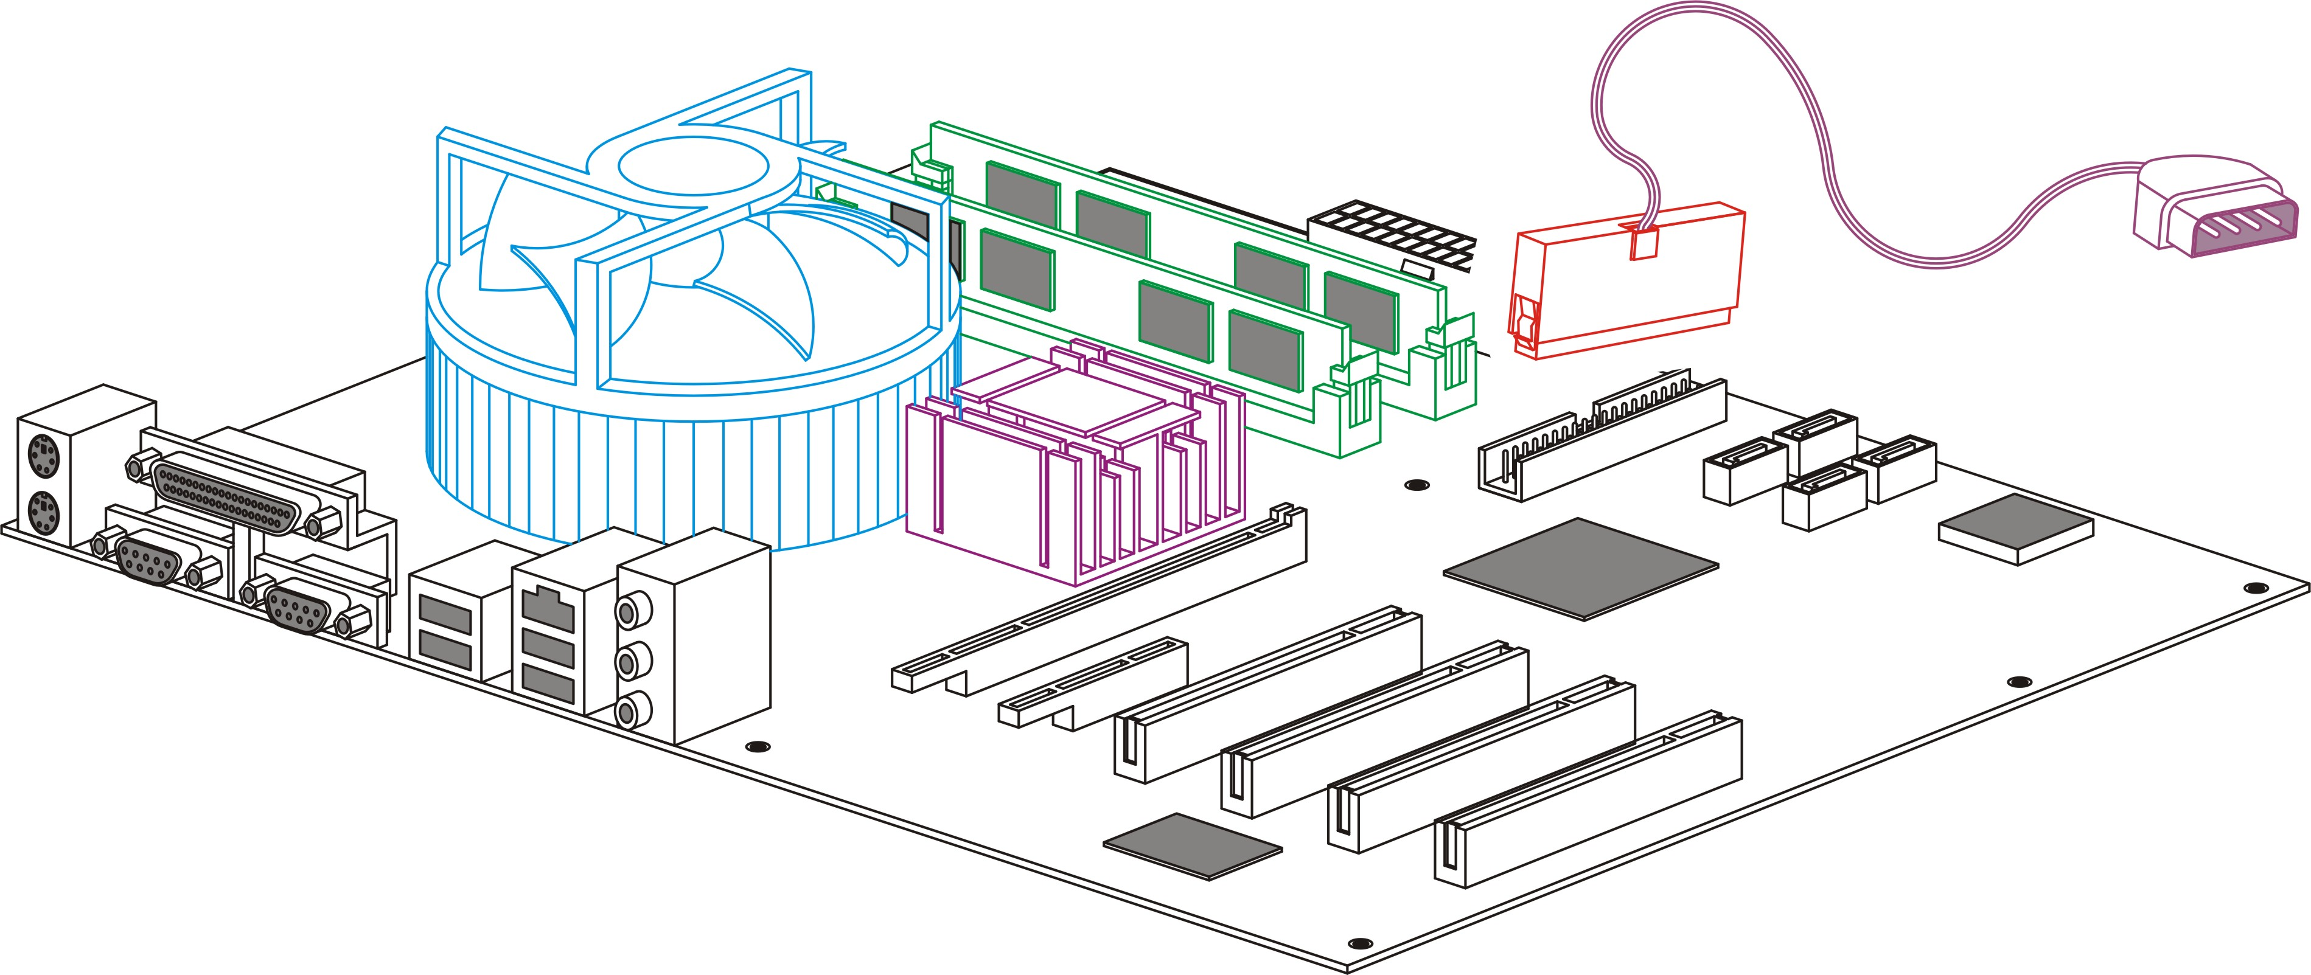
DVR module

Step 8: Connect the audio cable
We will provide one audio cable to connect motherboard and VP-41 for audio function. Please attach the audio cable from the internal CD1 connector on the motherboard to the audio connector of first VP41 video capture card.

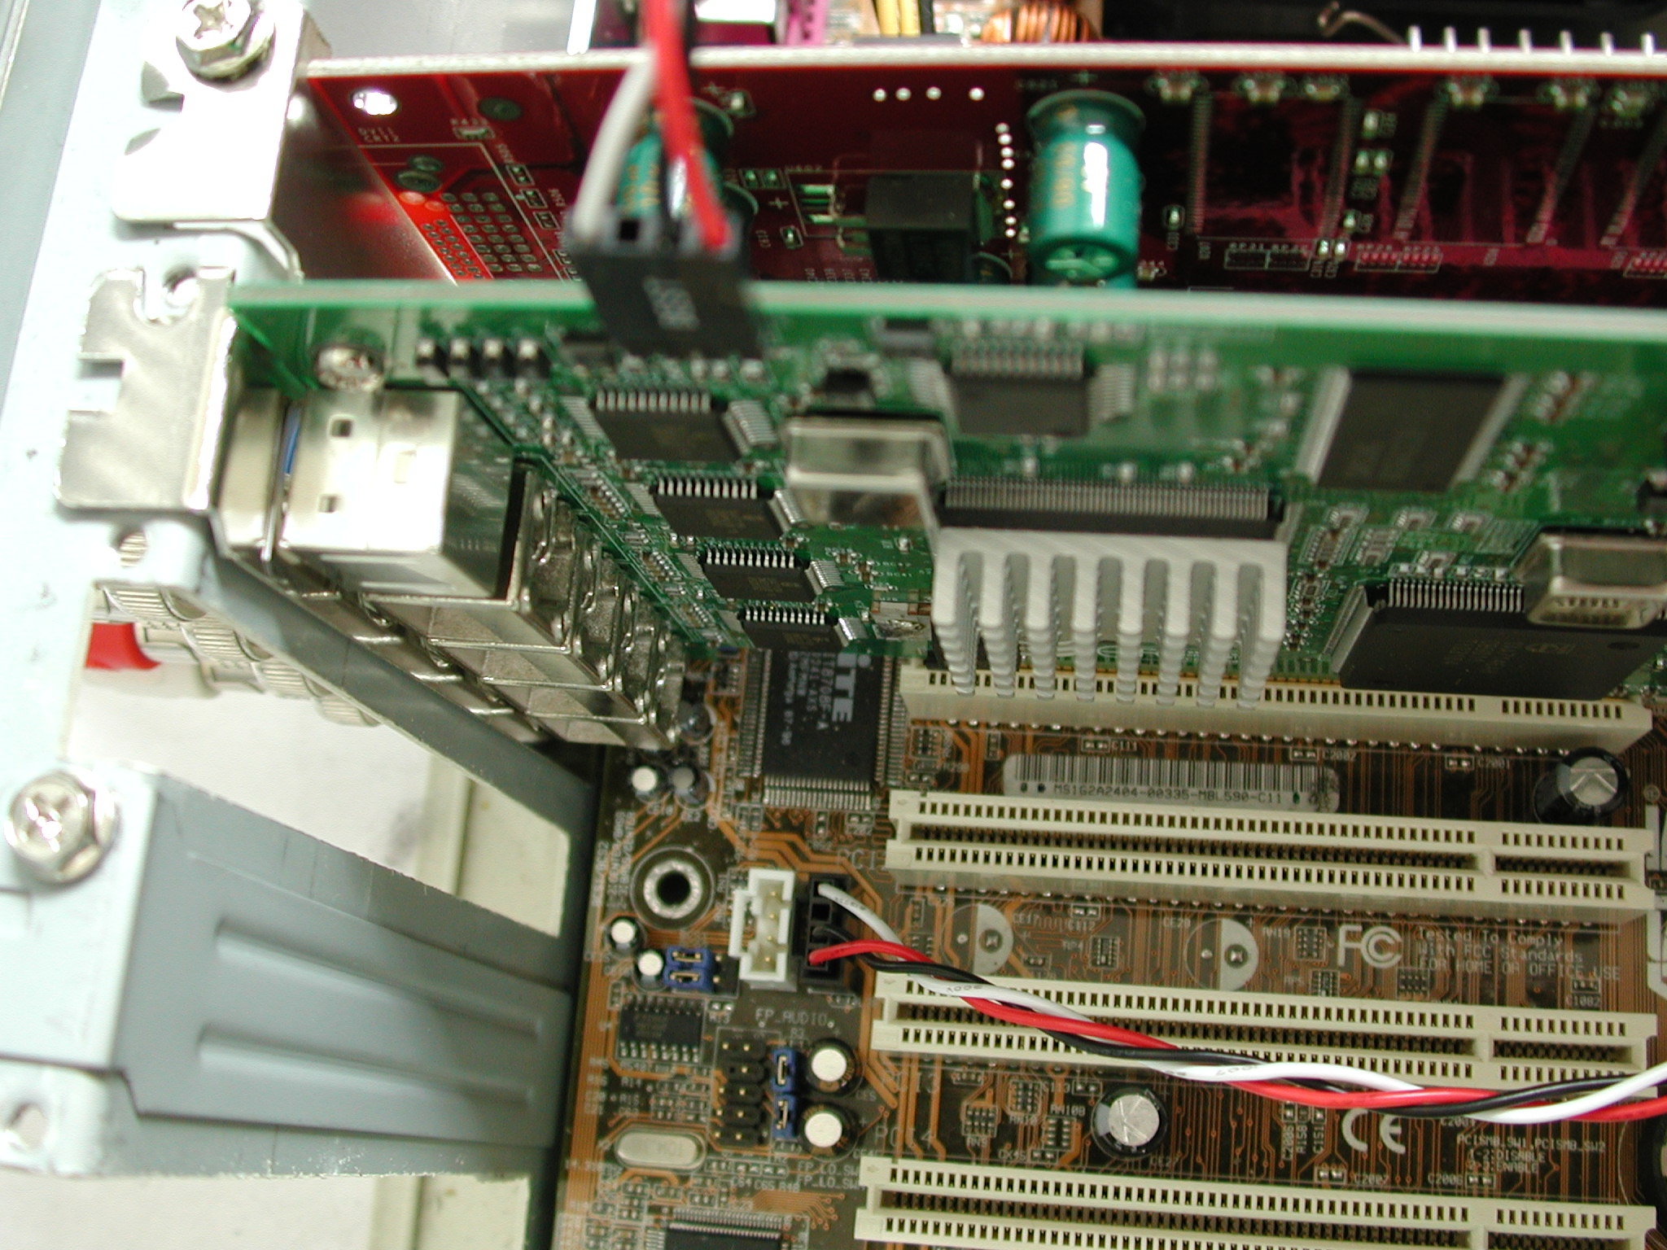
The audio connector of VP41
The internal CD1 connector of motherboard

Power Supply
We recommend a 400W ATX power supply for the DVR unit.

1.5 Power On
After complete the installation, you can power on the PC as usual. Live videos should be displayed on VGA screen if everything is OK and cameras are connected.

1.6 Configuration
When you get videos display on VGA screen, you can configure the VP-101 PC DVR unit using mouse or the IrDA controller comes with the VP-101 package. Please refer to User manual “Chapter 3 operating DVR by mouse , Chapter 4 Operating DVR by IrDA controller.

Change from GUI mode to IR mode
Default operation mode is GUI mode. DVR provides a GUI mode with mouse support. Be sure to plug in a PS2 mouse at the back of the unit before or when it starts to boot. Go to the running mode in the system settings. Change it from mouse mode to IR mode. The unit will reboot.

