1. Install EXT2IFS to Your PC
EXT2IFS, an installed File System Driver, allows you to view Linux System files on Windows System. If you are a Windows user, then you need to install EXT2IFS to your PC before you start using HDcopytool to convert the raw data.
To get the software EXT2IFS, you can visit http://uranus.it.swin.edu.au/~jn/linux/ext2ifs.htm and download EXT2IFS. A detailed description about the software also can be found on the website.

2. Converting Process
The following sections guide you step by step to convert the raw data into the Windows-acceptable files.
- Download EXT2IFS to your PC through above website address.
- Remove the HDD from DynaGuard 500 series DVR and install the removed HDD into your PC. When done, reboot the PC.
- Extract and Launch EXT2IFS Setup Wizard.
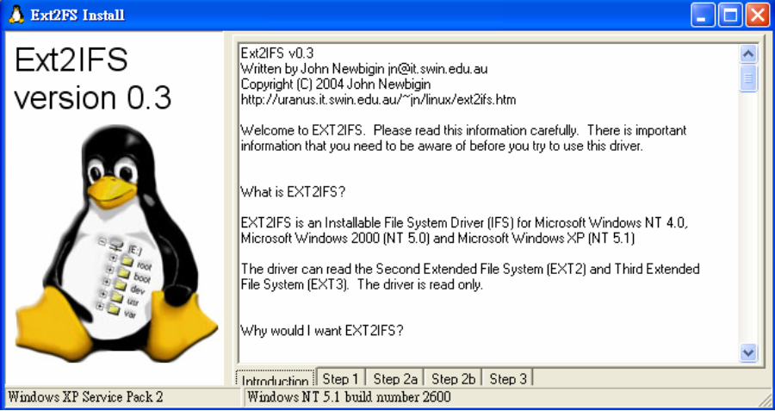
- Click <Step1> sheet, and then choose <Install to SystemRoot> and <Start drive on boot> options. When done, click <Install Drive> button.
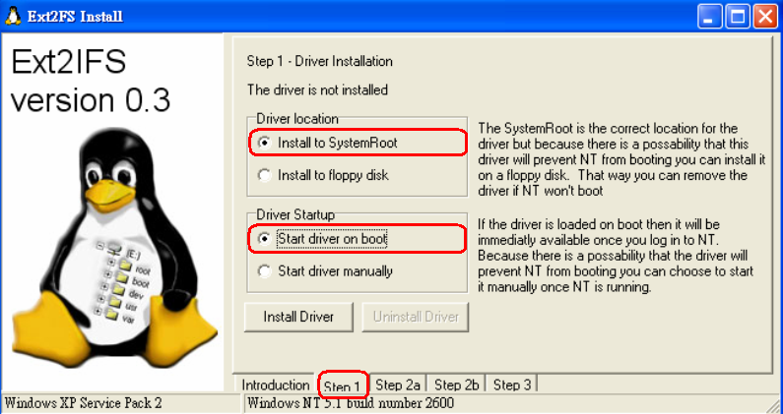
- Click <Step2b> sheet. Click <Drive> to assign each partition drive.
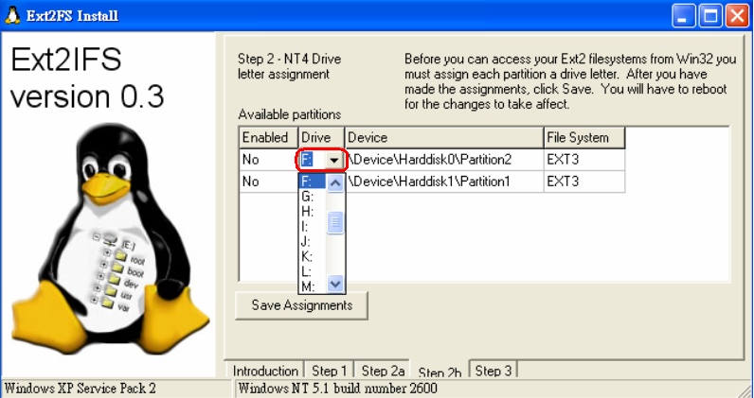
- After the assignments are made, click <Save Assignments> button.
- Click <Step3> sheet. Then click <Start Drive> button.
- After last step is done, reboot the PC for the changes to take effect. The HDD will be added into your PC’s database after rebooting.

