This Quick Guide is for quick installing and connecting the Network Speed Dome Camera. For details, please refer to the camera’s User Manual and Installation Guide.

Switch Definition

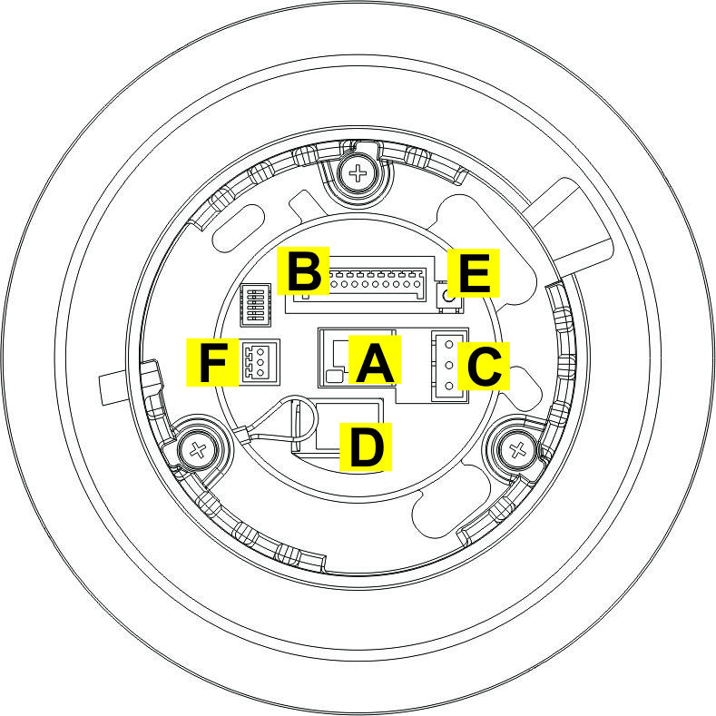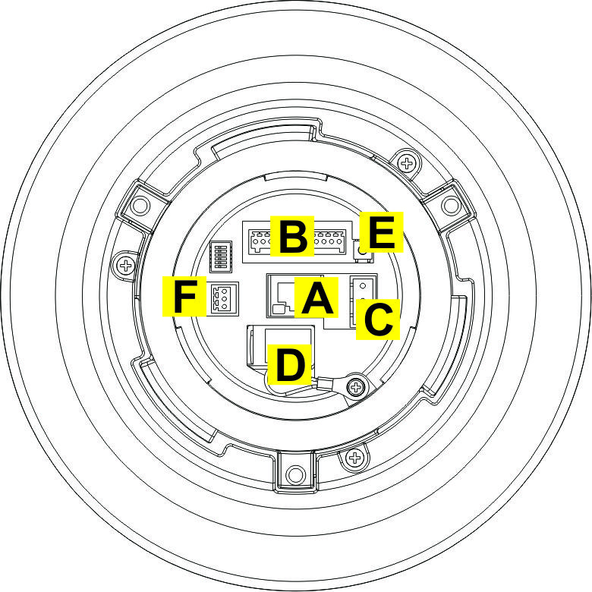
Indoor Outdoor

A | RJ-45 Connector
B | ALARM I/O
C | Power
D | Micro SD Card Slot
E | Factory Reset Button
F | Audio I/O

Power & Audio Connector Definition
Please refer to the illustrations below to connect power core through the supplied power adaptor, and set up the audio according to the Audio pin definition.

Power Connector Audio Connector

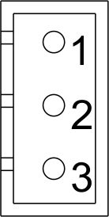 | Pin | Definition |  | 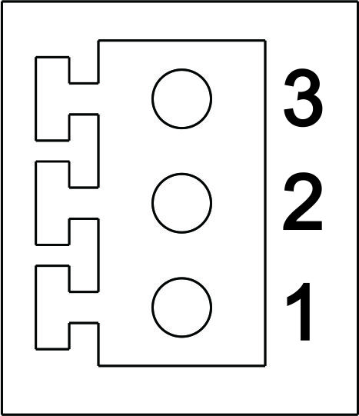 | Pin | Definition
 | 1 | AC 24_1 |  |  | 1 | LINE_OUT
 | 2 | FG |  |  | 2 | GND
 | 3 | AC 24_2 |  |  | 3 | LINE_IN

To power up the Camera, users could choose either High power over Ethernet or AC 24V. To use High power over Ethernet, please connect the Ethernet cable to the Camera’s Ethernet Port and plug the other end of the cable into an IEEE 802.3at 60W High Power over Ethernet (HPoE) injector. To use AC 24V, please plug the AC 24V cable into the Camera’s Power Connector to power up the Camera.


Please kindly check the pin definition of the Power Connector listed above before connecting to the power source. The AC24V power source should be connected to the first and third pin. The unit might be damaged with wrong connection.
Alarm I/O Connector Definition
When cabling, please refer to the table below for pin definition of the Alarm I/O setting

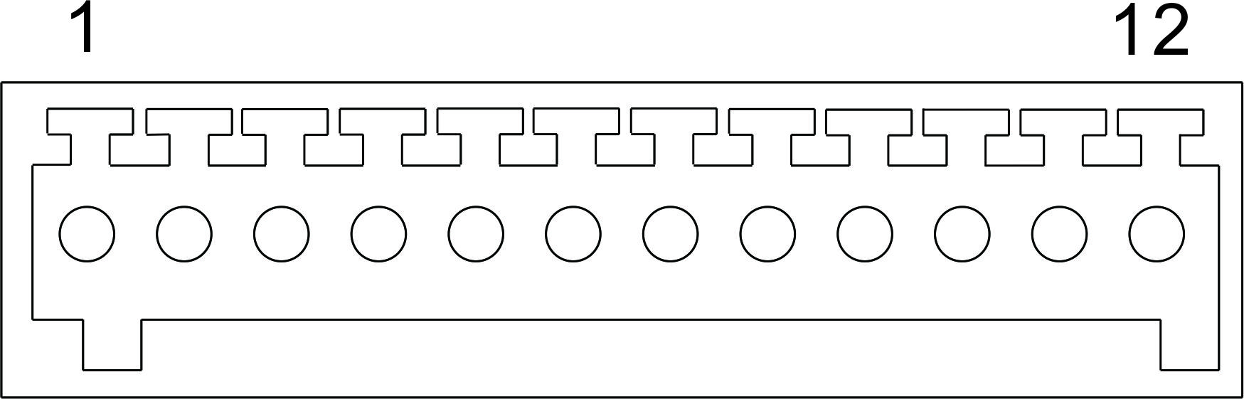

Pin | Definition |  | Pin | Definition
1 | ALARM_OUT_NO_1 |  | 7 | ALARM_OUT_COM_2
2 | ALARM_OUT_NC_1 |  | 8 | GND
3 | ALARM_OUT_COM_1 |  | 9 | ALARM_IN_4
4 | GND |  | 10 | ALARM_IN_3
5 | ALARM_OUT_NO_2 |  | 11 | ALARM_IN_2
6 | ALARM_OUT_NC_2 |  | 12 | ALARM_IN_1

Before Login to the Camera
A client program will be automatically installed on your PC when connecting to the network Speed Dome Camera. Before logging in to the Dome Camera, please ensure downloading the ActiveX control is allowed by either changing the ActiveX controls and plug-ins or setting Internet’s security level to default. For further details, please refer to the network Speed Dome Camera’s Software Guide.

ActiveX Controls and Plug-ins Settings | Internet Security Level
Step 1: Start the Internet Explorer (IE).  Step 2: Select <Tools> from the main menu of the browser. Then Click on <Internet Options>.  Step 3: Click on the <Security> tab and select “Internet”, and click on <Custom level> to change ActiveX settings.  Step 4: Set “ActiveX controls and plug-ins” items to <Prompt> or <Enable>. | Step 1: Start the IE.  Step 2: Select <Tools> from the main menu of the browser. Then Click on <Internet Options>.  Step 3: Click on the <Security> tab and select “Internet.”  Step 4: Down the page, press “Default Level” and click on <OK> to confirm the setting. Close the browser window, and open a new one later for accessing the IP Camera

Camera Login
The network Speed Dome Camera’s default IP address is: 192.168.0.250. Therefore, to access the camera for the first time, set the PC’s IP address as: 192.168.0.XXX; for example:

IP Address: 192.168.0.100
Subnet Mask: 255.255.255.0

Login ID & Password
- Key in the camera’s IP address in the URL bar of the Web browser window and hit “Enter.”
- Enter the default user name (Admin) and password (1234) in the prompt request dialogue. Note that user name is case sensitive.

Install the ActiveX Control
- After connecting to the network Speed Dome Camera, the request for installing the ActiveX control will appear just below the URL bar.
- Right Click on the information bar, and press “Install ActiveX Control…” to permit ActiveX control installation.

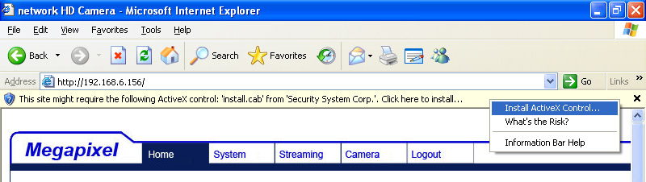

- In the pop-up security warning window, click on <Install> to start downloading DC Viewer software on the PC.
- Click on <Finish> after DC Viewer installation is complete.

Browser-based Viewer
The main page of the network Speed Dome Camera user interface is as shown below.
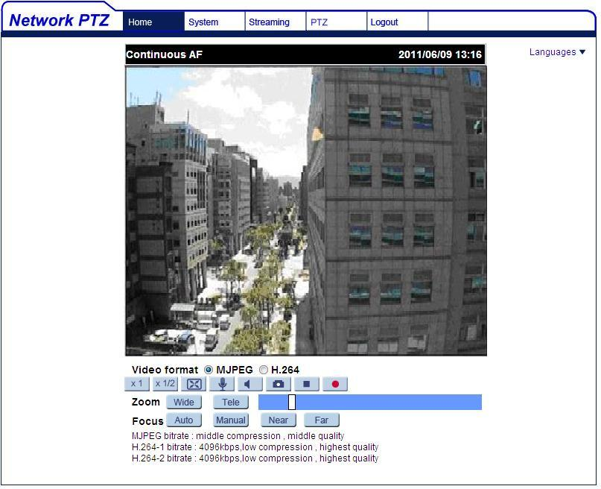

Network High Speed Dome IP Camera
Quick Guide

Ver. 1.3

