The Quick Guide is for quick installing and connecting the Full HD Multiple Streams Compact Bullet IP Camera. For details, please refer to the User Manual of the IP Camera.

Camera’s Connectors
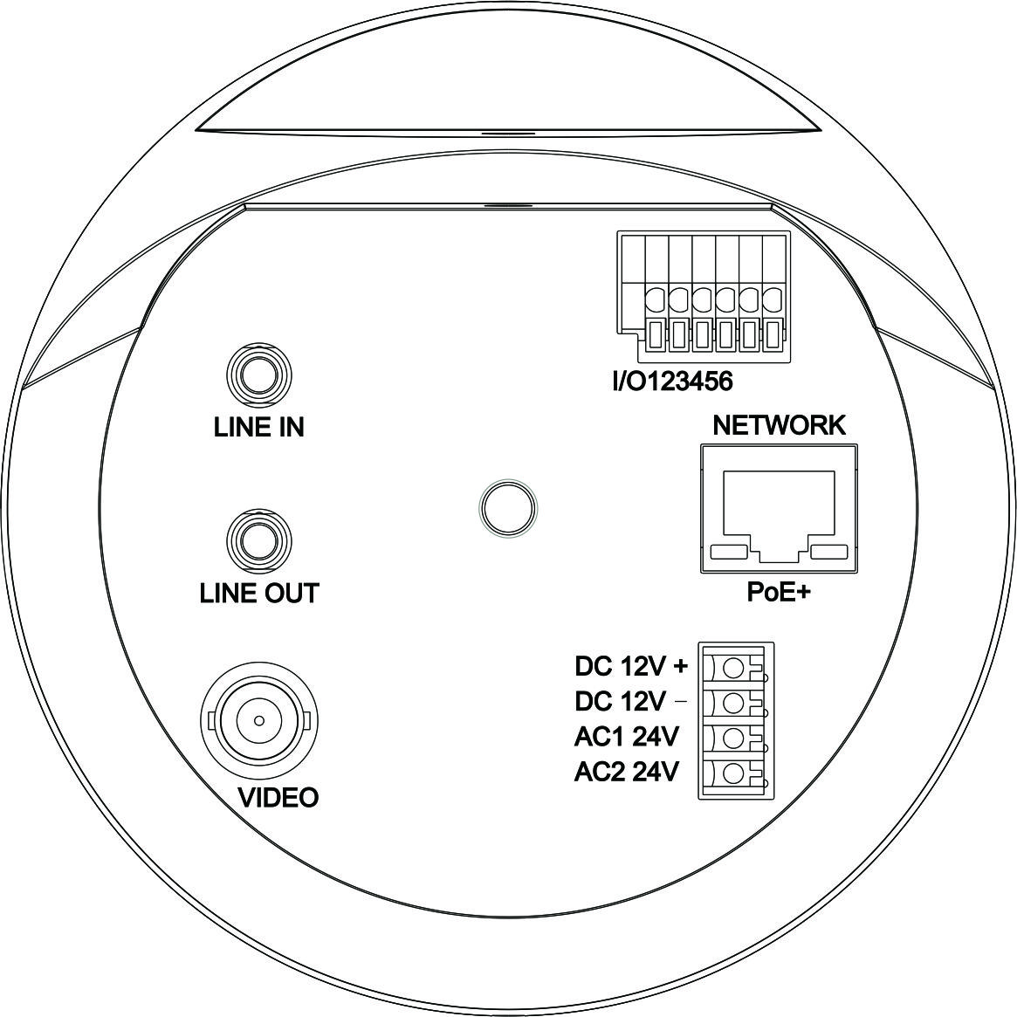
Connector | Definition
LINE IN & LINE OUT | Two-way audio transmission
VIDEO (BNC Connector) | For video output
Alarm I/O and RS485 | 1 | Input − | 4 | Output +
Alarm I/O and RS485 | 2 | Input + | 5 | D +
Alarm I/O and RS485 | 3 | Output − | 6 | D −
PoE NETWORK | For Ethernet Cable and PSE connection
Network LEDs | Network connection and activity indication
DC 12V + | DC 12V and AC 24V connectors
DC 12V −
AC1 24V
AC2 24V

Micro SD Card Slot / Default Button (For Different Lens Types)
The positions of the Micro SD Card Slot and the Default Button for each lens type are shown as below.

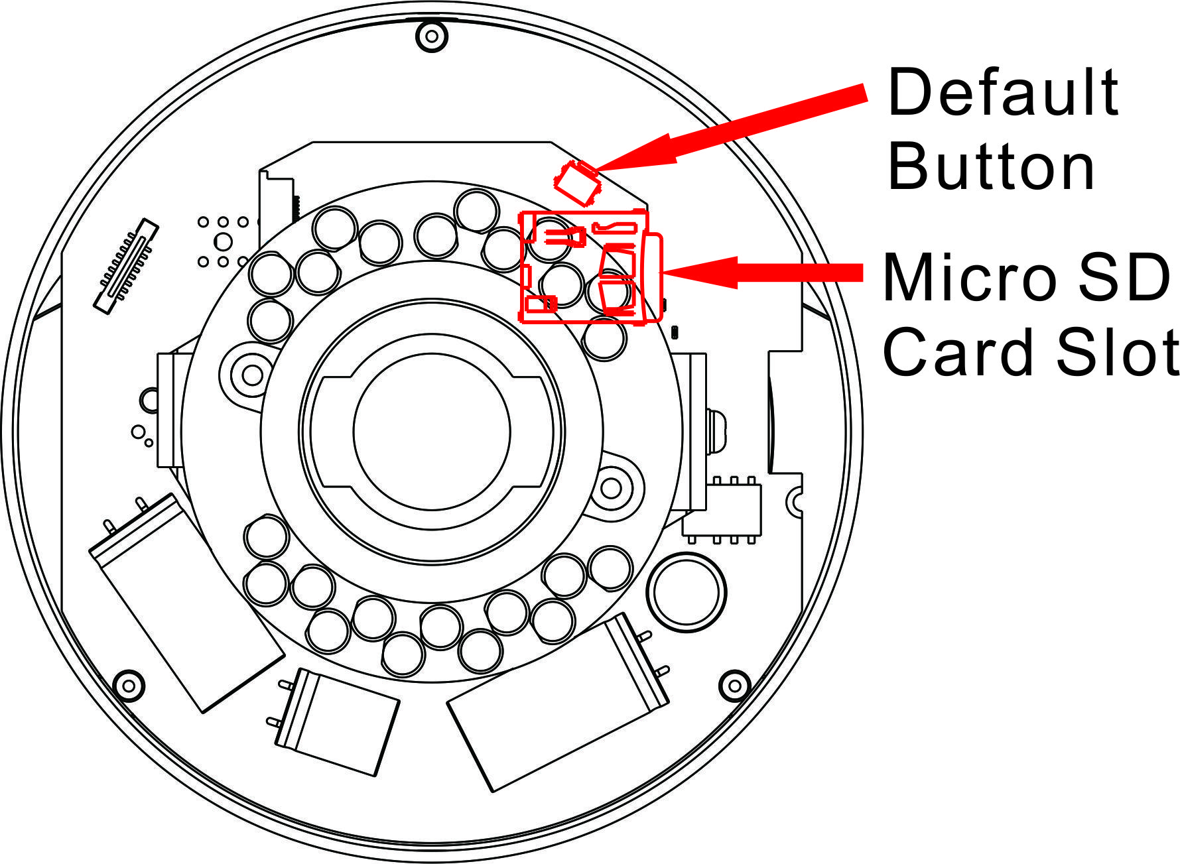  3x Zoom Lens | 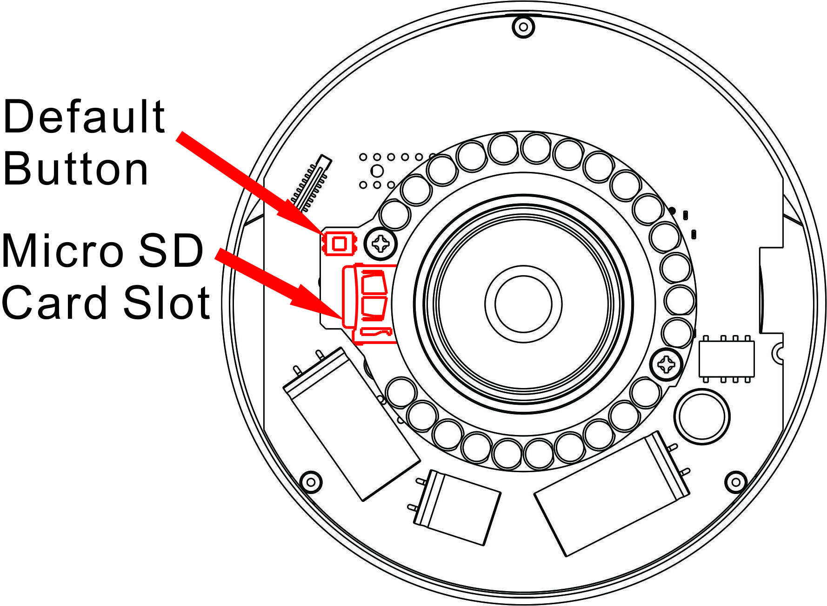  Board Lens | 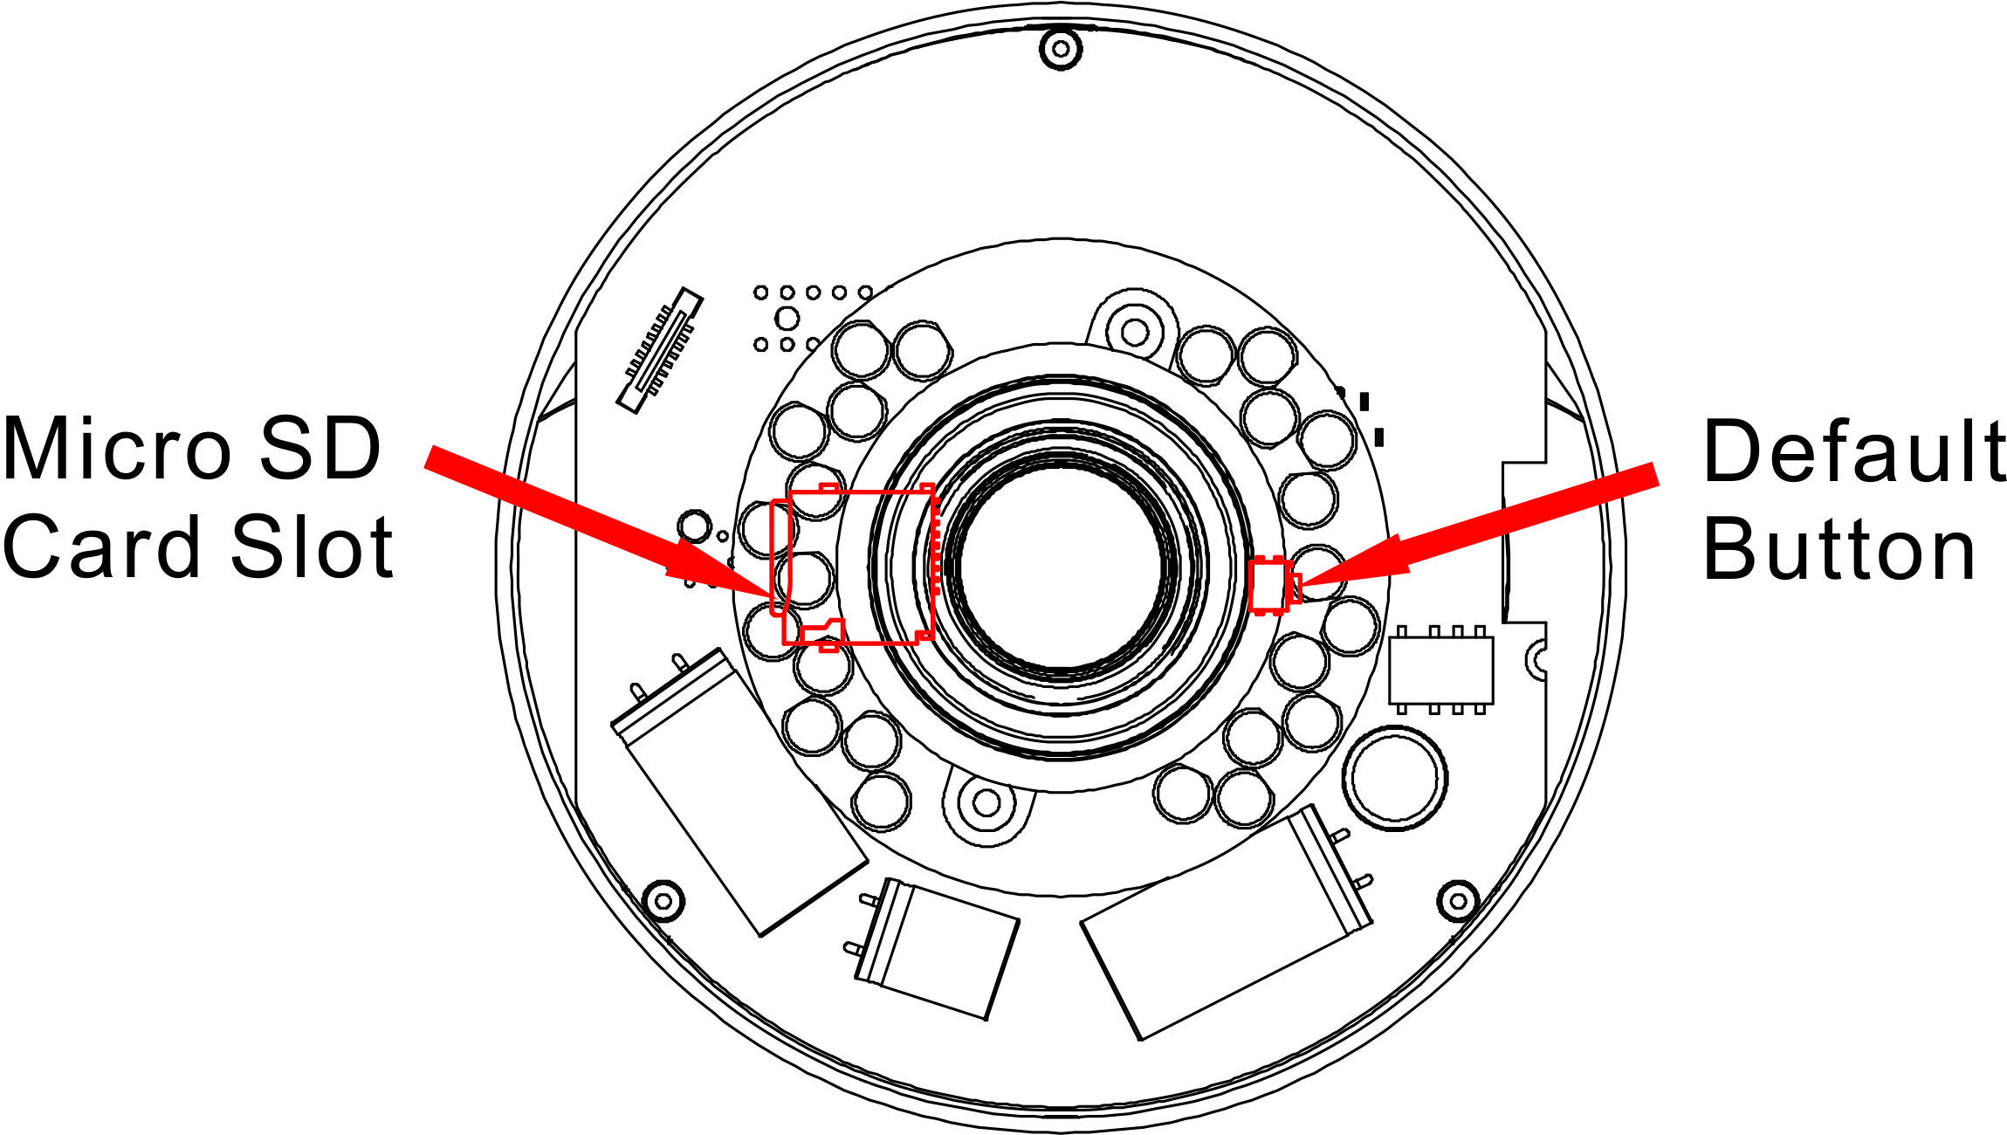  Vari-focal Lens

Micro SD Card Slot
Insert the SD Card in the Micro SD Card Slot to store videos and snapshots.

Default Button
Press the button with a proper tool to restore the system to default setting.
IP Camera Installation
Please follow the instructions below to complete IP Camera installation.

Power up the Camera
To power up the IP Camera, please plug the camera’s DC 12V / AC 24V cable into the power terminal block. Alternatively, connect the Ethernet Cable to the camera’s RJ-45 port and plug the other end of the Cable into a PoE switch.

NOTE: If PoE is used, make sure Power Sourcing Equipment (PSE) is in use in the network.

Ethernet Cable Connection
Connect one end of the CAT5 Ethernet Cable to the RJ-45 connector of the IP Camera, and the other end of the cable to the network switch or PC.

NOTE: In some cases, Ethernet Crossover Cable might be needed when connecting the IP Camera directly to the PC.

NOTE: Check the status of the link indicator and activity indicator LEDs. If the LEDs are unlit, please check LAN connection.

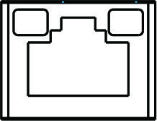 | Green Link Light indicates good network connection.  Orange Activity Light flashes for network activity indication.

Before Login to the IP Camera
A client program will be automatically installed on the PC when connecting to the IP Camera. Before logging in to the IP Camera, please ensure downloading the ActiveX control is allowed by either changing the ActiveX controls and plug-ins or setting Internet’s security level to default. For further details, please refer to the User Manual of the IP Camera.

ActiveX Controls and Plug-ins Settings | Internet Security Level
Step 1: Start the Internet Explorer (IE).  Step 2: Select <Tools> from the main menu of the browser. Then click on <Internet Options>.  Step 3: Click on the <Security> tab and select “Internet”, and click on <Custom level> to change ActiveX settings.  Step 4: Set “ActiveX controls and plug-ins” items to <Prompt> or <Enable>. | Step 1: Start the Internet Explorer (IE).  Step 2: Select <Tools> from the main menu of the browser. Then click on <Internet Options>.  Step 3: Click on the <Security> tab and select “Internet”.  Step 4: Down the page, click “Default Level” and click on <OK> to confirm the setting. Close the browser window, and open a new one later for accessing the IP Camera.

IP Camera Login
The IP Camera’s default IP address is: 192.168.0.250. Therefore, to access the IP Camera for the first time, set the PC’s IP address as: 192.168.0.XXX; for example:
IP Address: 192.168.0.100
Subnet Mask: 255.255.255.0

Login ID and Password
- Key in the IP Camera’s IP address in the URL bar of the Web browser window and click on <Enter>.
- Enter the default user name (Admin) and password (1234) in the prompt request dialogue. Note that user name is case sensitive.

Install the ActiveX Control
- After connecting to the IP Camera, the request for installing the ActiveX control will appear just below the URL bar.
- Right click on the information bar, and then click on “Install ActiveX Control…” to permit ActiveX control installation.
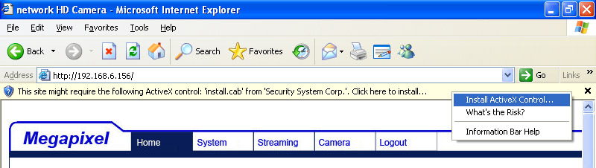
- In the pop-up security warning window, click on <Install> to start downloading DC Viewer software on the PC.
- Click on <Finish> after DC Viewer installation is complete.

Browser-based Viewer
The main page of the IP Camera user interface is shown as the figure below. Please note that function buttons will vary depending on the camera model.

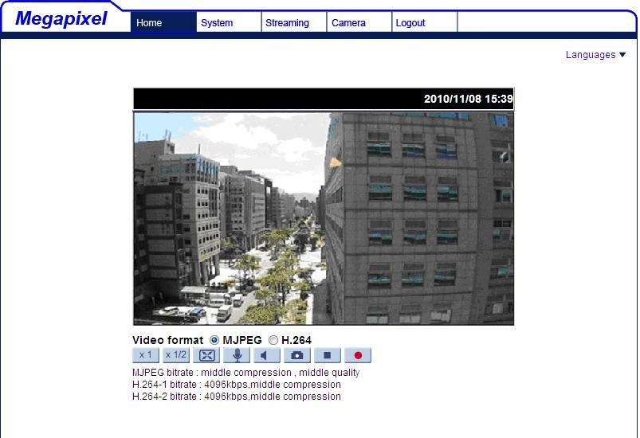

Full HD Multiple Streams Compact
Bullet IP Camera
Quick Guide

Ver. 1.1

