The Quick Guide is for quick installing and connecting the Full HD Multiple Streams Zoom AF IP Camera_SFP. For details, please refer to the User’s Manual of the IP Camera.

Camera Rear Panel

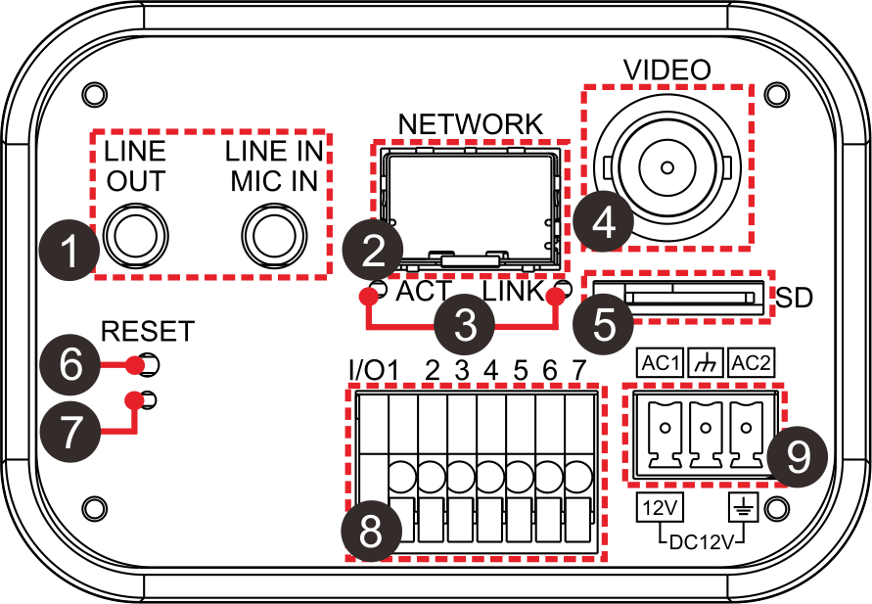

No. | Connector | Definition
1 | LINE OUT & LINE IN / MIC IN | Two-way audio transmission
2 | SFP NETWORK | For SFP Cable connection
3 | Network LEDs | Network connection and activity indication
4 | VIDEO (BNC Connector) | For video output
5 | microSD Card Slot | For videos and snapshots storage
6 | Default Button | Press the button with a proper tool to reset the system.
7 | Power LED | Power connection indication (green light)
8 | Alarm I/O | 1 | Output+ | 5 | GND
8 | Alarm I/O | 2 | Output− | 6 | D−
8 | Alarm I/O | 3 | Input+ | 7 | D+
8 | Alarm I/O | 4 | Input−
9 | AC 24V / DC 12V Connector | AC1 | AC 24V: Power-1 | 12V | DC 12V: Power
9 | AC 24V / DC 12V Connector | 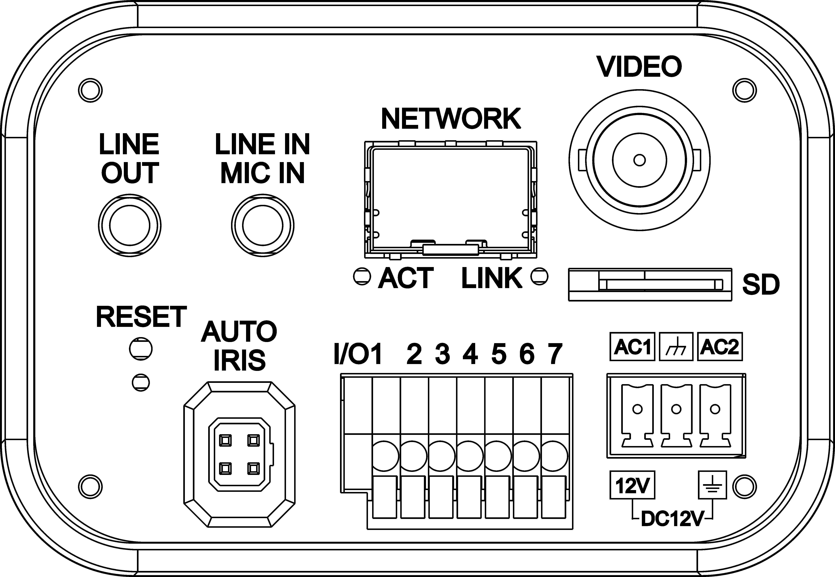 | AC 24V: GND | - | DC 12V: Reserved
9 | AC 24V / DC 12V Connector | AC2 | AC 24V: Power-2 |  | DC 12V: GND

IP Camera Installation
Please follow the instructions below to complete the IP Camera installation.

Power up the Camera
Plug the camera’s DC 12V / AC 24V Cable into the power outlet to power up the camera.

Network Connection
Connect one end of the SFP Cable to the SFP Connector of the IP Camera, and connect the other end of the cable to the Network Switch.


NOTE: Check the status of the link indicator and activity indicator LEDs. If the LEDs are unlit, please check the LAN connection.

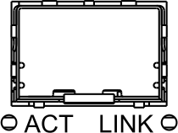 | Green Link Light indicates good network connection.  Orange Activity Light flashes for network activity indication.

Before Login to the IP Camera
A client program will be automatically installed to the PC when connecting to the IP Camera. Before logging in to the IP Camera, please ensure downloading the ActiveX control is allowed by either changing the ActiveX controls and plug-ins or setting Internet’s security level to default. For further details, please refer to the User’s Manual of the IP Camera.

ActiveX Controls and Plug-ins Settings | Internet Security Level
Step 1: Start the Internet Explorer (IE).  Step 2: Select <Tools> from the main menu of the browser. Then click <Internet Options>.  Step 3: Click the <Security> tab and select “Internet”, and click <Custom level> to change ActiveX settings.  Step 4: Set “ActiveX controls and plug-ins” items to <Prompt> or <Enable>. | Step 1: Start the Internet Explorer (IE).  Step 2: Select <Tools> from the main menu of the browser. Then click <Internet Options>.  Step 3: Click the <Security> tab and select “Internet”.  Step 4: Down the page, click “Default Level” and click “OK” to confirm the setting. Close the browser window, and open a new one later for accessing the IP Camera.

IP Camera Login
The IP Camera’s default IP address is: 192.168.0.250. Therefore, to access the IP Camera for the first time, set the PC’s IP address as: 192.168.0.XXX; for example:
IP Address: 192.168.0.100
Subnet Mask: 255.255.255.0

Login ID and Password
- Key in the IP Camera’s IP address in the URL bar of the Web browser window and press “Enter”.
- Enter the default user name (Admin) and password (1234) in the prompt request dialogue. Note that user name is case sensitive.

Install the ActiveX Control
- After connecting to the IP Camera, the request for installing the ActiveX control will appear just below the URL bar.
- Right click on the information bar, and click “Install ActiveX Control…” to permit ActiveX control installation.

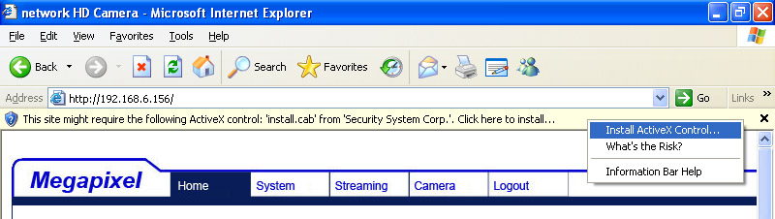

- In the pop-up security warning window, click “Install” to start downloading DC Viewer software on the PC.
- Click “Finish” after DC Viewer installation is complete.
Browser-based Viewer
The main page of the IP Camera user interface is shown as the figure below. Please note that function buttons will vary depending on the camera model.

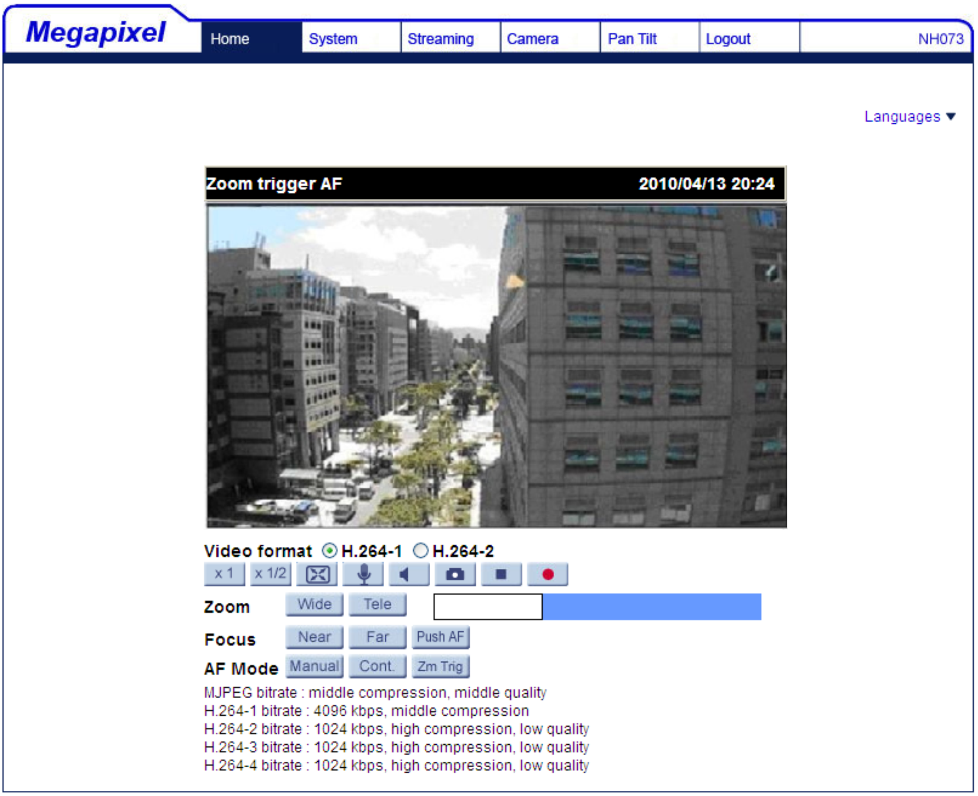

Full HD Multiple Streams
Zoom AF IP Camera_SFP
Quick Guide

Ver. 1.1

