D7715 Mini Dome Series

Features:
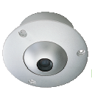
- Color Aluminum Flush Mount Dome Camera
  - 1/ 4” color DSP CCD with mini fixed iris lens 3.6mm
  - 2 Lux illumination
  - 350 TV lines
  - Auto white balance control
  - NTSC or PAL system
D7715-L
  - Size 86 x 57mm

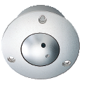
- Color Aluminum Flush Mount Pin-Hole Dome Camera
  - 1/ 4” color DSP CCD with pin-hole lens 5.5mm
  - 2 Lux illumination
  - 350 TV lines
  - Auto white balance control
  - NTSC or PAL system
  - Size 86 x 57mm

D7715-P

Overview:

- D7715-L
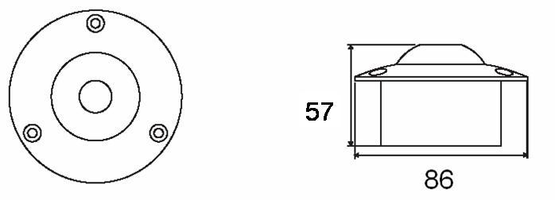
- D7715-P
DYNAC●L●R
SPECIFICATION
ITEMS | D7715-L | D7715-P
TYPE | COLOR
SIGNAL FORMAT | PAL/ NTSC
PICK UP DEVICE | 1/4” CCD IMAGE SENSOR
PICTURE ELEMENTS | EIA/ NTSC: 512 H x 492 V, CCIR/ PAL 512 H x 582 V
HORIZONTAL RESOLUTION | 350 Lines
MINI ILLUMINATION | 2 Lux
HORIZ. SYNC. FREQUENCY | EIA / NTSC: 15.734 KHz - CCIR / PAL: 15.625 KHz
VERTICAL FREQUENCY | EIA / NTSC: 60 Hz – CCIR / PAL: 50 Hz
CLOCK FREQUENCY | EIA: 19.0699 MHz – CCIR: 18.9375 MHz
SCANNING SYSTEM | 2:1 INTERLACE
S/N RATIO | 46 dB
ELECTRONIC SHUTTER | Up to 1/125,000 sec.
LENS | Board Lens 3.6 mm / F 2.0 | Pin-Hole 5.5 mm / F 3.5
WHITE BALANCE | AUTO TRACING
BACK LIGHT COMPENSATION | NO
AUTO GAIN CONTROL | NO
GAMMA | 0.45
VIDEO OUTPUT | 1Vp-p, 75 Ohms
POWER SUPPLY | 12VDC (+ / - 0.5V)
POWER CONSUMPTION | 90mA
DIMENSIONS Dx H mm | Φ86x57
WEIGHT g. | 340 | 315
FIXATION Screws | 3
STORAGE TEMPERATURE | –30 to +60℃
OPERATING TEMPERATURE | –10 to +45℃
Remark:
The camera are only operated with regulative adaptor DC 12V,
AC to DC non-regulative adaptor may cause camera damaged.

PRODUCT SELECTION

D 7 7 1 5 - X1 X2
L: Board Lens
P: Pin-Hole
N: NTSC
P: PAL

Represented by:

Worldwide Distribution and Network
Developd and Manufactured by:

DYNACOLOR, Inc.
No. 116, Jou Tz St., Neihu, Taipei 114, Taiwan, R.O.C.
Tel: 886-2-2659-8898
Fax: 886-2-2659-8868
E-mail: sales@dynacolor.com.tw
Http://www.dynacolor.com.tw

