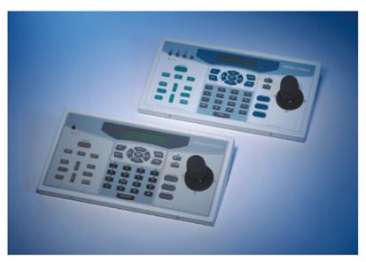
CCTV CONTROL KEYBOARD

MODEL D7312/ D7313
KEY FEATURES:

- RS-485 port for CCTV system control

- Built-in DSCP, Pelco D&P protocol

- Joystick control of PTZ functions

- Preset position and Cruise control

- Friendly user-interface

- Firmware upgrade via RS-232

- Control Dome cameras, P/T/Z Receivers, Multiplexers, DVR

- Maximum 255 devices can be controlled on the same bus, included 223 Dome Cameras or Receivers, 16 System Keyboards, 16 Multiplexers (or DVR) (only on D7313)

- Built-in Real Time Clock Generator (only on D7313)

- Support System Clock Calibration (only on D7313)

- Optional 3-axis joystick

D7312 BASIC CONTROL KEYBOARD
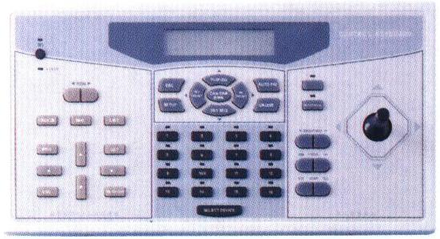

D7313 ADVANCED CONTROL KEYBOARD

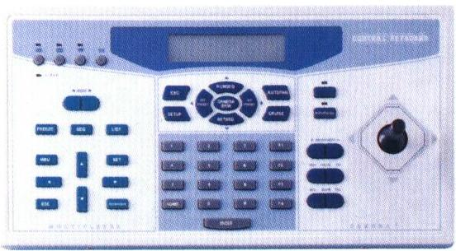

DYNACLR
MKPB-731X-02

MODEL: D7312/D7313
CCTV CONTROL KEYBOARD

The D731X family of control keyboards harness the latest hardware and firmware technology to give you the best solution for surveillance control. Multiple cameras, Multiplexers and DVRs can be effortlessly setup and controlled via the D731X. Through the built-in RS232 port, the latest control firmware can be upgraded easily, assuring you the flexibility of customization unmatched by others.

D7312 is a basic control keyboard used for smaller CCTV system, up to 16 dome cameras are mapping directly to the 16 hot keys on the front panel. D7313 is useful in a large CCTV system, up to 223 Dome cameras and 16 Multiplexers/ DVRs can be controlled by 16 keyboards.

Dependability and ultra high reliability are key factors in the D731X design cycle. Every D731X is assembled with meticulous care and thorough testing at our ISO9001 compliant factory. High performance, reliability, and reasonable pricing, D731X is an ideal solution to your tough surveillance requirement.

D7312/D7313 SPECIFICATION
FEATURES

FRONT PANEL
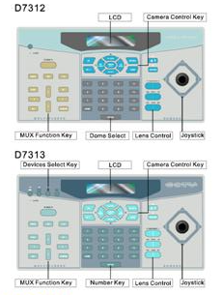
REAR PANEL
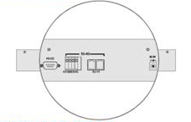

PRODUCT SELECTION
D7313-H

2:Basic control K.B. S:2-axis joystick
3:Advanced control K.B. H:3-axis joystick

**This document is subject to change without notices.

Model | D7312 | D7313
Power | 12 Volts DC
Power consumption | 5W
RS-485 port | RJ-11 x2, Terminal Block x1
RS-232 port | DSUB 9pin x1
Device on bus | 16 cameras,  1 multiplexer | 255 devices  maximum
Pan/Tilt Control | Manual Pan / Tilt
Pan/Tilt Control | Preset: 128 maximum
Pan/Tilt Control | Auto Pan : On / Off
Pan/Tilt Control | Sequence : On / Off
Pan/Tilt Control | Cruise: On / Off
Lens Control | Zoom: Tele / Wide
Lens Control | Focus: Near / Far, Auto
Lens Control | Iris: Open / Close, Auto
Camera Setup | Yes
Multiplexer Control | Channel Select: 16
Multiplexer Setup | Yes
Dimension (mm) | 330(L) X 175(W) X 65(H)
Operation Temperature | 0°~40°C
Operation Humidity | Below 90%
Weight | 1.5kg

SYSTEM ARCHITECTURE
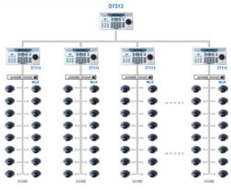

Keyboard Type
Joystick Type

Developed and Manufactured by:
Represented by:

Worldwide Distribution and Service Network
DYNACOLOR, INC.
彩富電子股份有限公司
台北市內湖區洲子街116號
No. 116. Jou Tz Street, Neihu, Taipei 114, Taiwan, R.O.C.
Tel: 886-2-2659-8898 FAX: 886-2659-8868
http: //www.dynacolor.com.tw
E-mail: sales@dynacolor.com.tw

