Vandal-Proof
IR Dome Camera
Instruction Manual

VER.:1.0, NO.:R040118/2
Thank you very much for purchasing our product. Before operating this product, please read this instruction manual carefully to ensure proper use.
1. Safety Precautious
- When in use, please avoid directly contacting the eyes and do not touch the camera body, for it can be heated up to 70℃.
- When installing the camera, please avoid pointing it directly to paper or flammable materials.
- The camera is normal to be heated up to, under operation.
- Although the camera is provided with tempered glass, please avoid all direct contact to eliminate contamination, and use cotton balls dipped in cleaning alcohol to clean the window.
2. Description
This inbuilt Infrared Illuminator camera uses a high sensitive 1/3” interline transfer Charge Coupled Device (CCD) Image Sensor, and all state circuitry, which provides extremely long life and high reliability. Offers excellent image quality and functions with low lag and high burn resistance. IR illuminator module has power saving features, built-in with automatic light-source control/ the infrared illuminator is activated automatically (ON/ OFF) when the luminous intensity drops.
Highly resistant to shock and vibration, easy to install, it is an excellent choice for your CCTV system.

3. Feature
- With built-in high quality CCD Camera and high performance Infrared Illuminator modules.
- Infrared Illuminator has effective range of up to 20 meters, assists camera in providing a clear image when under completely dark area.
- Infrared Illuminator has built-in 24 pieces 850nm wavelength infrared Light-Emitting Diode.
- Built-in light-source sensor can automatically turn on/off the infrared illuminator by detecting the light source of environment.
- Wide angle lens permits three-axis camera movement (X-axis/ Y-axis/ Z-axis). Allows precise adjustment to any preferred angles, and enables optimum beam angles.

4. Contents

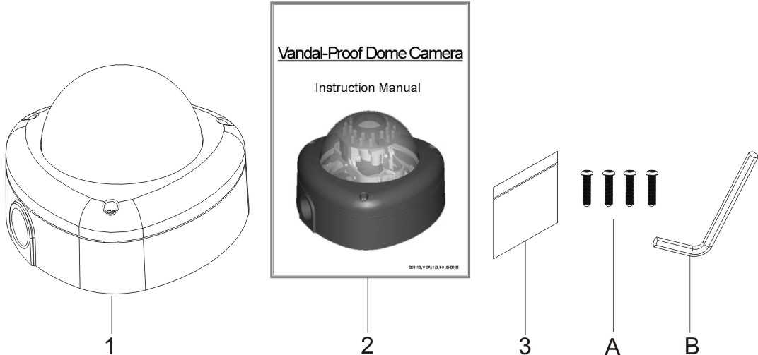

ITEM | Name of Part |  | Quantity
1 | Vandal-Proof Dome CCD Camera |  | 1
2 | Instruction Manual |  | 1
3 | Appurtenances |  | 1
 | A | Fix retaining screw for bracket | 3
 | B | L-Wrench | 1

5. Installation & Operation
- Using the provided L-Wrench, loosen the tamper-resistant housing cover screws (with screws still attached on the cover).
The unit has a factory installed side conduit entry and one may adjust the cables to back conduit entry according to installation requirement (as shown on figure 1).
Note! The inner parts may differ depending on the camera model type.

Figure 1

- Set the mounting base onto the wall or ceiling and center it over the mounting hole, using the four retaining screws for the main body supplied by the accessory package (as shown on figure 2).

Figure 2

- Set the proper image by moving the camera body (some model types limits the PCB board to 180° rotational adjustment) and set the focus by turning the lens to the left or right direction.

- Vari-Focal Dome CCD Camera Operate
(4.1) Once the picture appears on the monitor, open the cover adjust the lens’ wrench of “NEAR←→FAR” to get the view zoom that you desire, then adjust the focus wrench of the Lens to obtain the best picture. After adjustment, tighten these two wrenches.

(4.2) DIP Switch Setting
Figure 3
(4.2.1) Flickerless Function
Set switch-OFF/F.L. to Flicker to enable flickerless function, in this mode, the switch-AES/OFF is auto disabled.
(4.2.2) AGC-Hi / AGC-Lo Function
Adjust the switch to AGC indicates AGC-Hi and OFF indicates AGC-Low. This switch setting to High or Low of the AGC maximum gain. AGC-Hi mode--The maximum AGC gain is approximately 26dB. AGC-Lo mode--The maximum AGC gain is approximately 16dB.
(4.3) AUTO IRIS FUNCTION
When using an Auto Iris Lens, the Switch-AES/OFF should be in the OFF position to disable the AES function. Adjust the LEVEL with the VR to proper level.
(4.4) BLC FUNCTION
Set Switch-OFF/BLC to BLC to enable Back Light Compensation (BLC) function.
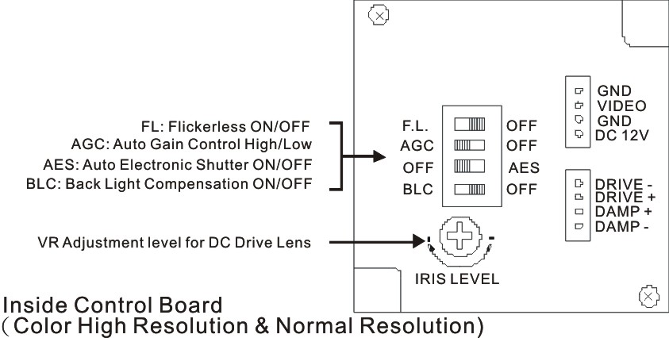

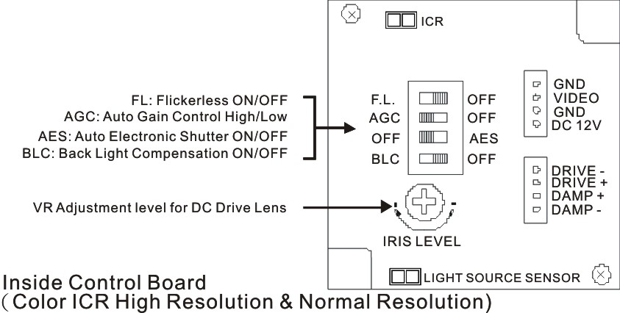

- When the camera focus adjustments has been completed, using the provided L-Wrench to fasten the tamper-resistant housing to the main body (as shown on figure 4).

Figure 4

- Connect the Video Output to the monitor or other video device through a 75 Ohms type coaxial cable. Connect the AC/DC-Terminator with power source (as shown on figure 5).

To Monitor

To DC 12V Power Source
(Option: AC 24V/ DC 12V Dual Model)

Figure 5

- When using the side conduit cabling, it is suggested to use metal cover over the cables to prevent external damage and as to weatherproof prevention, please wined the weatherproof adhesive tape (P.T.F.E. THREAD SEAL TAPE) onto the metal cover before installation (as shown on figure 6 ).

Figure 6

6. Specification
According to the camera purchased, select and refer to the appropriate specification below:
Image Device | 1/3“ Color SONY  Super HAD |  | 1/3“ Color SONY  Super HAD (Hi-Res.) |  | 1/3“ Color SONY  Ultra Super HAD  (Hi-Res.)
Picture Elements | NTSC: 510×492  PAL: 500×582 |  | NTSC: 768×494  PAL: 752×582
Resolution | 380 TVL |  | 470 TVL |  | 550 TVL
Min. Illumination | 0.2 Lux/ F2.0 | 0.05 Lux/ 2.0 (Ex-View) | 0.3 Lux/ F2.0 | 0.15 Lux/ F2.0  (Ex-View) | 0.4 Lux/ F2.0
S/N Ratio | More than 48dB
Auto Electronic Shutter | NTSC: 1/60s~1/100,000s, PAL: 1/50s~1/110,000s ON/ OFF, switch-able.
Flickerless Mode | NTSC: 1/100s, PAL: 1/120s ON/OFF, switch-able.
Gamma Characteristic | 0.45
Iris Control | DC Drive
Lens Furnished | Vari-Focal Lens and Vari-Focal Lens with ICR
White Balance | Auto
Gain Control | Hi/ Low
Back Light Compensation | ON/ OFF
Synchronous System | Internal, Negative sync.
Video Output | 1 Vp-p/ 75 Ohms.
Scanning System | Interlace 2:1
Infrared Luminary | 24 pieces IR-LED
Wavelength | 850nm
Illuminate Distance | 20M
Illuminator Active Limit | 5Lux
Power Supply | DC12V ±10％, DC12V/AC24V
Power Consumption | IR ON: DC/ 460mA max.  IR OFF: DC/ 250mA max.
Storage Temp. | -20℃ to 60℃ (-4℉ to 114℉)
Operating Temp. | -10℃ to 50℃ (14℉ to 122℉)
(Note: Design and specifications are subject to change without prior notice.)

