Infrared Illumination Camera
Instruction Manual
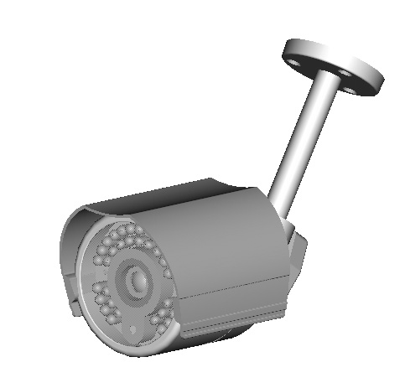

VER.:1.0, NO.:040126

Thank you very much for purchasing our product. Before operating this product, please read this instruction manual carefully to ensure proper use.
1. Safety Precautious
- When in use, please avoid directly contacting the eyes and do not touch the camera body, for it can be heated up to 70℃, under operation.
- When installing the camera, please avoid pointing it directly to paper or flammable materials.
- Although the camera is provided with tempered glass, please avoid all direct contact to eliminate contamination, and use cotton balls dipped in cleaning alcohol to clean the window.
2. Description
This inbuilt Infrared Illuminator camera uses a high sensitive 1/3” interline transfer Charge Coupled Device (CCD) Image Sensor, and all state circuitry, which provides extremely long life and high reliability. Offers excellent image quality and functions with low lag and high burn resistance. IR illuminator module has power saving features, built-in with automatic light-source control (CDS CONTROL)/ the infrared illuminator is activated automatically (ON/ OFF) when the luminous intensity drops.
Highly resistant to shock and vibration, easy to install, it is an excellent choice for your CCTV system.

3. Feature
- With built-in high quality CCD Camera and high performance Infrared Illuminator modules.
- Infrared Illuminator has effective range up to 20 meters and wide angle at 18°&35°, also assists cameras in providing a clear image when under completely dark area.
- Infrared Illuminator has built-in 24 pieces 850nm wavelength infrared Light-Emitting Diode.
- Built-in Cds light-source sensor can automatically turn on/off the infrared illuminator by detecting the light source of environment.
- Weatherproof suitable for indoor and outdoor use.

4. Contents

Item | Name of Part |  | Quantity
1 | Infrared Camera |  | 1
2 | Mounting Bracket Bag |  | 1
 | A | Base plate | 1
 | B | Supporting Arm | 1
 | C | Mounting Bracket | 1
3 | Appurtenances Bag |  | 1
 | D | Fix retaining screw for Bracket | 3
 | E | Anchor | 3

5. Installation & Operation
STEP 1: Use the 3 screws provided to attach the mounting bracket to the surface or wall, assemble all spare parts to the base plate and tighten the camera wing nut (as shown on Figure 1).

Figure 1

STEP 2: Screw the mounting bracket into the camera mounting post; then adjust the camera to approximate location and tighten the camera wing nut (as shown on Figure 2).

Figure 2

STEP 3: Connect the Video Output and the Power Input (as shown on Figure 2).

6. Specification
According to the camera purchased, select and refer to the appropriate specification below:
Color Camera
Image Device | 1/3” Color SONY  Super HAD |  | 1/3“ Color SONY  Hi-Res. Super HAD
Picture Elements | NTSC: 510492  PAL: 500582 |  | NTSC: 768494  PAL: 752582
Resolution | 380 TVL |  | 470 TVL
Min. Illumination | 0.2 Lux/ F2.0 |  | 0.4 Lux/ F2.0
S/N Ratio | More than 48 dB
Electronic Shutter | NTSC: 1/60~1/100,000, PAL: 1/50~1/110,000
Gamma | 0.45
Lens Furnished | Board Lens f3.6 mm / F2.0 (optional: 4.3 / 6.0 / 8.0 / 12 mm)
White Balance | Auto
Gain Control | Auto
Sync. System | Internal
Video Output | 1 Vp-p/ 75 Ohms
Infrared Luminary | 24 pieces IR-LED
Wavelength | 850 nm
Beam Spread Angle | 18°&35°
Illuminate Distance | 20M
Illuminator Active Limit | 3 Lux
Waterproofing Criterion | IP 66
Power Supply | DC12V±10%
Power consumption | 5.1W (IR ON)  1.4W (IR OFF) | 5.8W (IR ON)  2.2W (IR OFF)
(Note: Design and specifications are subject to change without prior notice.)

