Space Dome Camera
Instruction Manual

VER.:1.0, NO.: R040160A/3

Thank you very much for purchasing our product. Before operating this product, please read this instruction manual carefully to ensure proper use.
1. Safety Precautious

 | Disposal of Old Electrical & Electronic Equipment (Applicable in the European Union and other European countries with separate collection systems).

- Please do not directly touch the sensor element. If necessary, use a soft cloth moistened with alcohol to wipe off any dust.
- Please be extra careful not to shake the camera.
- Please avoid places where there is direct sunlight.
- When using this camera in places where the lighting differs greatly, please use the auto iris lens with ND filter.
- Please avoid places where temperatures exceed 50℃ or more, high humidity or where direct rain drops hit, frequent vibrations, or shocks occur.
- During the night, if a minimum brightness of 0.1 Lux can not be achieved, install appropriate light fixtures.
- When the camera is not used, keep the lens or the lens cap attached to protect the sensor.
2. Description
The camera uses SONY high sensitive super HAD interline transfer image sensor, and employs digital signal processor (DSP) chip-set for image control, and all integrated state circuitry which provide extremely long life and high reliability. This camera offers excellent image quality with low lag and high burn resistance, and is not subject to distortions from magnetic fields.
Highly resistance to shock and vibration, easy to install, this camera is a very good choice for your color CCTV system.

3. Feature
- Sony Super HAD CCD sensor.
- Employs Digital Signal Processor (DSP) chip-set for image control.
- Pixel number: NTSC=380K/ PAL=440K (EIA=440K/ CCIR=380K) for high resolution models, and NTSC=250K/ PAL=290K (EIA=290K/ CCIR=250K) for normal resolution models.
- High sensitivity, low smear, high anti-blooming and high S/N ratio.
- Powerful functions: Auto Electronic Shutter (AES), Auto Iris (AI), Auto Gain Control (AGC), Auto White Balance (AWB), and Back Light Compensation (BLC).
4. Contents

Item | Name of Part |  | Quantity
1 | Camera |  | 1
2 | Instruction Manual |  | 1
3 | Appurtenance Bag |  | 1
 | A | Screws | 4

5. Installation & Operation
- Remove the dome cover from the mounting base by rotating the dome cover clockwise.
- Camera Image Adjustment:
    - 2-Axis – Set proper image by moving the camera module and set the focus by turning the lens to the left or right direction.
    - 3-Axis – First tilt then rotate the camera module to obtain desired viewing angle, and then turn the horizontal adjustment ring to correct the image and achieve proper orientation.

Shade Facing Left
Shade Facing Top

Note: When adjusting 3-Axis Vari-Focal lens, before following the Camera Image Adjustment setup, you must turn the horizontal adjustment ring so that the shaded area is facing toward you on the top or left side.

- Connect the video output to the monitor or other video device through a 75 Ohms type coaxial cable and the DC-Jack or AC/ DC-Terminator to the power source.

Note: Power adapter is sold separately.

- Vari-Focal Dome Operation Guide
Once the picture appears on the monitor, open the cover and adjust the lens wrench to “NEAR←→FAR”, get the view zoom that you desire, and then adjust the focus wrench of the lens to obtain the best picture. After adjustment, tighten both wrenches.

DIP Switch Setting
    - Flickerless Function
Set switch-OFF/ F.L. to Flicker to enable flickerless function, in this mode, the switch-AES/ OFF is auto disabled.
    - AGC-Hi/ AGC-Lo Function
Adjust the switch to AGC indicates AGC-Hi and OFF indicates AGC-Low. AGC-Hi mode--The maximum AGC gain is approximately 26dB. AGC-Lo mode--The maximum AGC gain is approximately 16dB.
    - Auto Iris Function
When using an auto iris lens, the switch-AES/ OFF should be in the OFF position to disable the AES function. Adjust VR to the proper level.
    - BLC Function
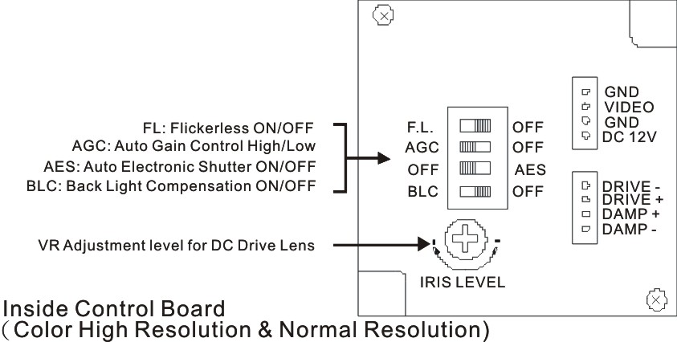
Set switch-OFF/ BLC to BLC to enable Back Light Compensation (BLC) function.

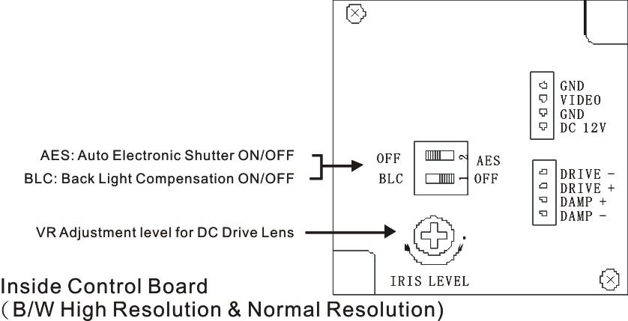

6. Specification
According to the camera purchased, select and refer to the appropriate specification below:
Color Camera
Image Device |  |  | 1/3“ SONY  Super HAD |  |  | 1/3“ SONY  Hi-Res. Super HAD |  | 1/3” SONY Ultra  Hi-Res. Super HAD |  | 1/4” SONY  Super HAD
Picture Elements |  |  | NTSC: 510 x 492  PAL: 500 x 582 |  |  | NTSC: 768 x 494  PAL: 752 x 582 |  |  |  | NTSC: 510 x 492  PAL: 500 x 582
Resolution |  |  | 380 TVL |  |  | 470 TVL |  | 550 TVL |  | 330 TVL
Min. Illumination |  |  | 0.2Lux/ F2.0 |  | 0.3Lux/ F2.0 | 0.3Lux/ F2.0 |  | 0.4Lux/ F2.0 |  | 0.5Lux/ F2.0
S/N Ratio |  |  | More than 48 dB
Electronic Shutter |  |  | NTSC:1/60~1/100,000, PAL:1/50~1/110,000
Flickerless Mode |  |  | On/ Off (NTSC: 1/100, PAL: 1/120)
Gamma |  |  | 0.45
Iris Control |  |  | DC Drive (for Vari-Focal Lens)
Lens Furnished |  |  | Vari-Focal Lens and Board Lens
White Balance |  |  | Auto
Gain Control |  |  | Hi/ Low (for Vari-Focal model) or Auto
Back Light Comp. |  |  | On/ Off
Video Output |  |  | 1 Vp-p/ 75 Ohms
Power Supply |  |  | DC12V±10% (optional: DC12V/ AC24V Dual)
Power  Consumption | Board Lens |  | 150mA max. | 160mA max. |  |  | 160mA max. |  | 200mA max. | 160mA max.
Power  Consumption | Board Lens+IR | IR On | 430mA max. | 440mA max. |  |  | 440mA max. |  | 480mA max. | 440mA max.
Power  Consumption | Board Lens+IR | IR Off | 150mA max. | 160mA max. |  |  | 160mA max. |  | 200mA max. | 160mA max.
Power  Consumption | Vari-Focal Lens |  | 180mA max. | 190mA max. |  |  | 190mA max. |  | 230mA max. | 190mA max.
Operating Temp. |  |  | -10℃ to 50℃

BW Camera
Image Device |  | 1/3“ SONY Super HAD | 1/3“ SONY  Hi-Res. Super HAD
Picture Elements |  | EIA: 510 x 492  CCIR: 500 x 582 | EIA: 768 x 494  CCIR: 752 x 582
Resolution |  | 420 TVL | 600 TVL
Min. Illumination |  | 0.1Lux/ F2.0 | 0.2Lux/ F2.0
S/N Ratio |  | More than 48 dB
Electronic Shutter |  | EIA:1/60~1/100,000, CCIR:1/50~1/110,000
Gamma |  | 0.45
Iris Control |  | DC Drive (for Vari-Focal Lens)
Lens Furnished |  | Vari-Focal Lens and Board Lens
Gain Control |  | Hi/ Low (for Vari-Focal model) or Auto
Back Light Comp. |  | On/ Off
Video Output |  | 1 Vp-p/ 75 Ohms
Power Supply |  | DC12V±10% (optional: DC12V/ AC24V Dual)
Power  Consumption | Board Lens | 140mA max. |  | 150mA max.
Power  Consumption | Vari-Focal Lens | 180mA max. |  | 200mA max.
Operating Temp. |  | -10℃ to 50℃
Note: Design and specifications are subject to change without prior notice.

