
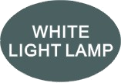
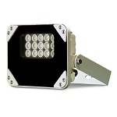
S-SG15A-W
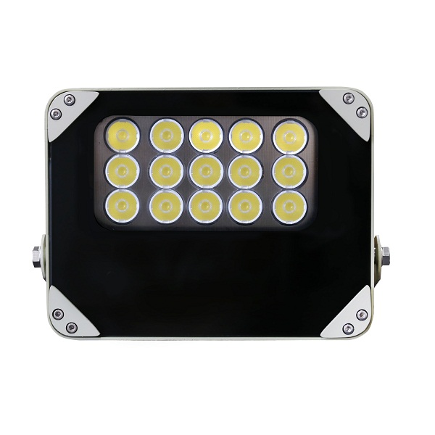

Product Overview
• Delivers high power white light for night time illumination, it’s significantly improves
monitor effects of night vision camera.
• Adopted with Compound-eye LED lens, the product performs more smoothly and
evenly light spot radiation.
• Excellent color rendering index, truly reserve object colors.
• Innovating high-efficiency driver provides a zero maintenance product.
• Good heat dissipation and IP66 waterproof aluminum housing ensures
efficient, reliable and continuous operation of LED.

Product Features
• Outstanding illumination performance
• Auto day/night switch, customize to be synchronized with camera
• To improve performance of night vision camera and enhance image quality
• IP66 waterproof, indoor/outdoor use
• Low temperature operate
• Lifetime 50,000 hours
• Energy saving technology
• 2 year warranty

Wide Application
Parking lot, Residence Community, Building, Road, Garden, Field

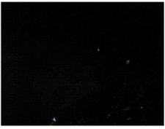
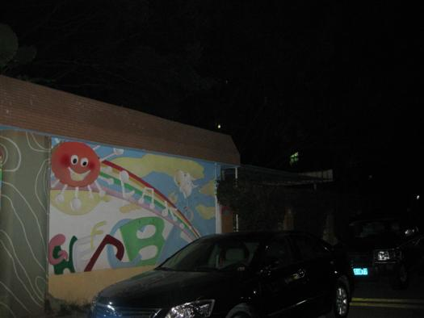
Viewing picture at night

With white light Without white light
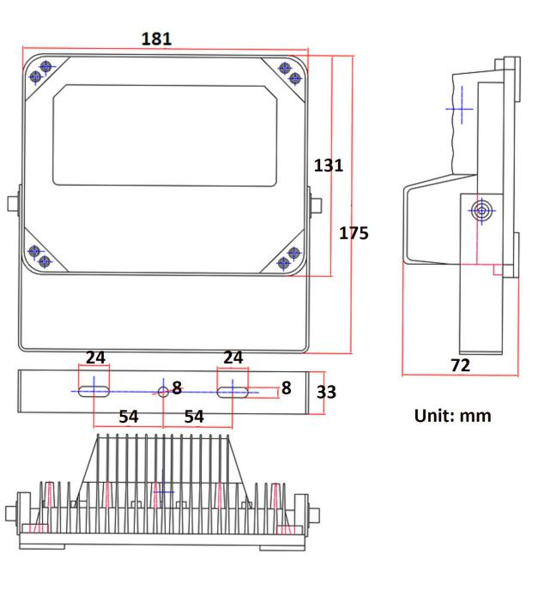
Technical Specification Drawing
LED type: 15pieces high power white light LED
Luminous flux: 1800lm
Color temperature: 5000K-6500K
Beam angle: 30 to 60°
Beam distance: 60 to 40m
Bracket: wall mount bracket
Working voltage: 85-265V AC
Power consumption: 18W
Day/night switch: automatic
Working temperatures: -30 to 50°C
Protection level: IP66
Color: beige
Panel: tempered glass panel
Housing: aluminum die-casting housing
N.W: 1.2KG
G.W: 1.5KG
Dimension: L181*H131*W72mm
Packing dimension: L210*H180*W100mm
Model for Selection Product Certificate



Model Beam angle Viewing distance
S-SG15A-30-A-W 30° 60m
S-SG15A-45-A-W 45° 50m
S-SG15A-60-A-W 60° 40m
*Viewing distance is tested by Sony 1/3 CCD Camera with
0.01LUX.
*To achieve the distance needed, please pay attention to your
camera specification and lens before purchase. It is normal
phenomenon that distance may vary due to different cameras
and lens.

