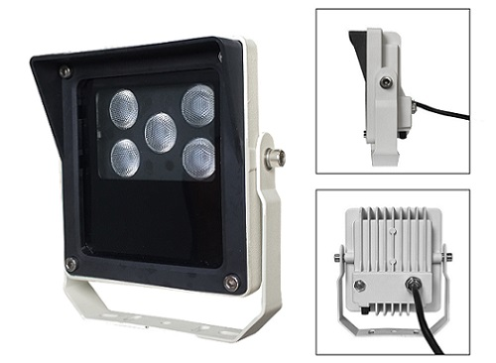
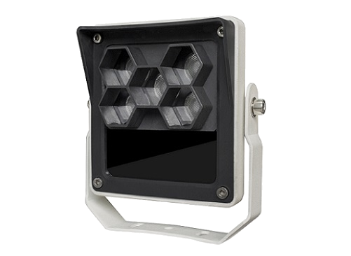
S-SA5F-W

Features Viewing picture at night
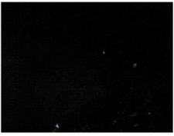
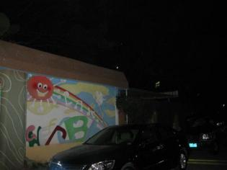
• Die casting aluminum housing, strong and durable
• One piece forming lens, uniform light spot and delicate
• Support power adjust
• Support light sensor sensitivity adjust
• Anti-dazzle panel optional, less influence of human eye
• IP66 waterproof
With white light Without white light

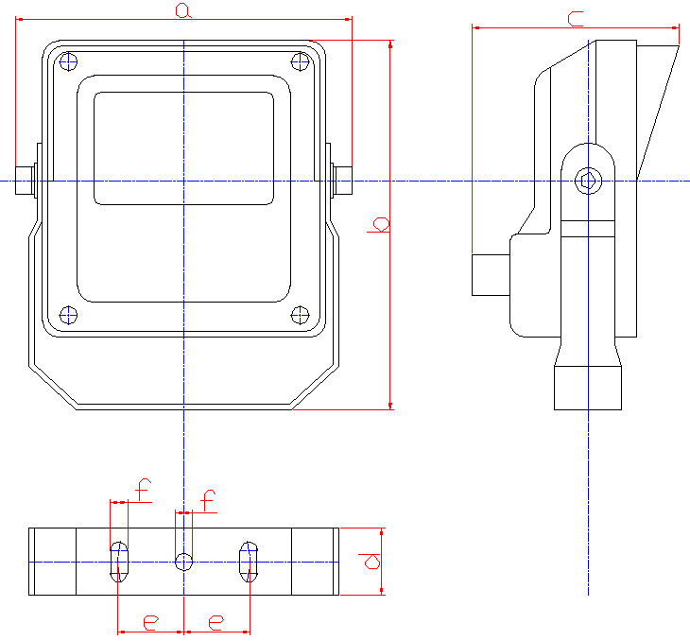
Technical Specification Drawing
Luminous flux: 910lm
Color temperature: 5500-6500K
Beam angle: 60°
Beam distance: 1m to 10m
Bracket: wall mount bracket
Working voltage: AC220V
Power consumption: ＜8W
Day/night switch: 0-50LUX adjustable
Brightness adjust: 5%-100% adjustable
Working temperatures: -20°C to 50°C
Protection level: IP66
Color: white
Panel: tempered glass
Housing: aluminum die-casting housing
a：125mm b：137mm
c：77mm d：25mm
e：24.5mm f：6.5mm

Net weight: 0.65kg
Gross weight: 0.8kg

Model for Selection Product Certificate


Model Beam angle Viewing distance*
S-SA5F-60-W 60° 1m-10m
*Viewing distance is depending on the technical
specification of camera and lens.

