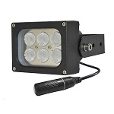
S-H061P-W
• The H series high power white light illuminator is a top quality LED light
source of night illumination with the longest service life.
• Deliver high power infrared light for CCTV & IP camera at night time and
improve performance of camera to get colorful pictures.
• PoE (Power over Ethernet) powered.

• 50,000 hours lifetime of LED.
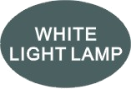
• 3/5 years warranty.

Professional Design
· It's designed to work with network camera via PoE(Power Over Ethernet).
· Two stages of constant current circuit avoid LED away from instantly impulse impact when started.
· Wide edge of silica gel circle and water stop line ensure IP66 waterproof and dustproof level.
· Twice direct cooling heat sink processing enable to increase the cooling coefficient and prolong the service life of the product.
· Patent design hexagonal spherical light sensor more accurately responses ambient brightness and
improves accuracy of automatic light control.
· Flexible angle adjustable bracket can extend the illuminance range widely.
• Robust cooling fin design is available the illuminator working at -40℃ to 50℃.
• Super energy saving circuit with low electrical power consumption.

Qualified Material
· Super power dot-matrix white light LED with strong light effect, long service life and low light decline.
· High efficient twice optical lens processing achieves 90% of the luminous efficiency.
· The housing adopts high thermal conductivity aluminum to enhance heat dispersion property.
· Stainless steel bracket and screw ensure low maintenance.

Wide Range of Application
· Recommended for security at ports, railway systems, border, prisons, traffic LPR/ANPR, ITS as well as large public places lighting.

Basic Function Viewing Picture at night
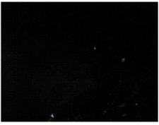

•To improve performance of the weak light camera,
thereby enhancing the picture effects at night.
•Conventional night monitoring
•The function of video analysis at night
•Reduce signal noise and other image distortion
•Reduce the network bandwidth requirements
With white light Without white light
•Energy saving by power factor correction
•Reduce the equipment cost
•Lower cost of installing and wiring
S-H061P-W Product certificate



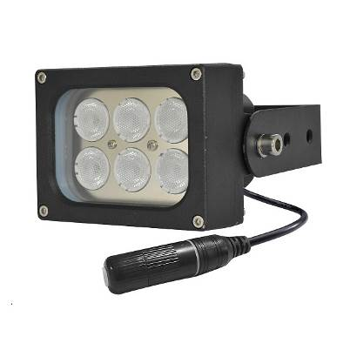

Technical Specification Drawing
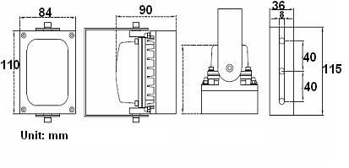
LED type 6pcs dot-matrix white light LED
Color temperature 3000-3500K/5500-6000K
Luminous Flux 660lm-720lm
Voltage PoE IEEE 802.3at
Power consumption 12W
Day and night switch Auto (build in photocell)
Cable IP66 RJ45 jack with Cat.5e 50cm
Mounting Wall mounting “U” bracket
Temperature -40℃ to 50℃
Grade of protection IP66
Color Black
Housing Aluminium
Panel High light transmittance toughened glass
N.W 1.0KG
G.W 1.3KG
Dimension 110*84*90mm
Packing dimension 180*160*135mm
Model for selection
Model Beam angle Viewing distance
S-H061P-15-W 15° 60m
S-H061P-30-W 30° 40m
S-H061P-45-W 45° 30m
S-H061EP-60-W 60° 25m
S-H061DP-75-W 75° 20m
S-H061EP-90-W 90° 10m
S-H061EP-120-W 120° 8m
*Viewing distance is tested by Sony 1/3 CCD Camera.
To achieve the distance needed, please pay attention to your camera specification and lens before purchase. It is normal phenomenon that distance may vary due to different cameras and lens.

