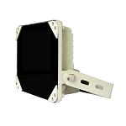
S-SE12-IR IR Illuminator
Deliver high power infrared light for CCTV & IP camera at night time and
improve performance of camera to get clear pictures.

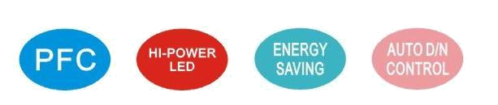
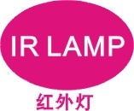
Product Features
• Precise secondary optical technology
The latest LED technology assures outstanding performance of LED with excellent luminous efficiency and more uniform illumination
• Independent innovation of high efficiency power drive schemes
Low failure rate of products is guaranteed because of professional in-house optimized independent circuit technology widely used in our LED illuminators for more than 5 years
• High thermal conductivity aluminum
Excellent thermal management not only reduces excess heat and brightness decay of LED but also ensures efficient, reliable and continuous operation of LED throughout its lifetime as 50,000 hours.
• Energy saving technology
All illuminators has energy saving circuit with low electrical power consumption.
• Thinner and lighter design
Our patent owned housing is designed for simple installation and easy operation to reduce construction difficulty.
• Warranty period
3 year warranty
Basic Function
•To improve performance of the weak light camera, thereby enhancing the picture effects at night.
•Conventional night monitoring
•The function of video analysis at night
•Reduce signal noise and other image distortion
•Reduce the network bandwidth requirements
•Energy saving by power factor correction
•Reduce the equipment cost
•Lower cost of installing and wiring
•Indoor and outdoor use
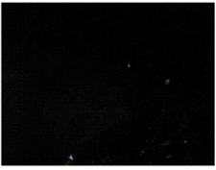
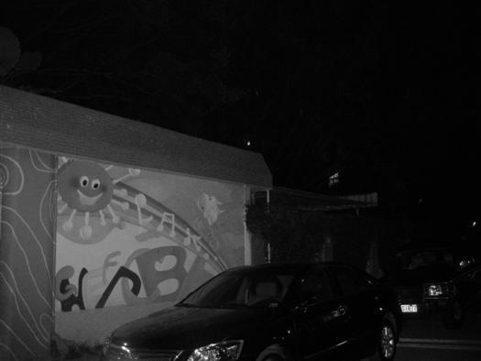
Viewing picture at night

With IR light Without IR light
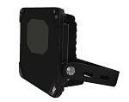
Picture Product Certificate
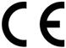

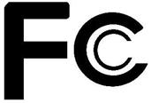
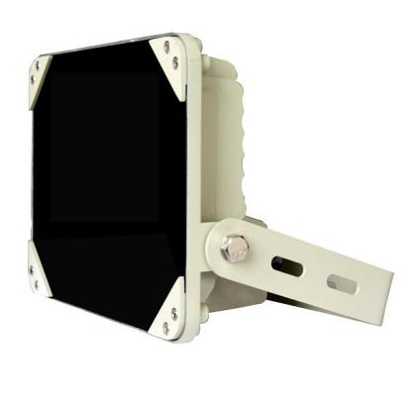

Black color

Technical Specification Drawing
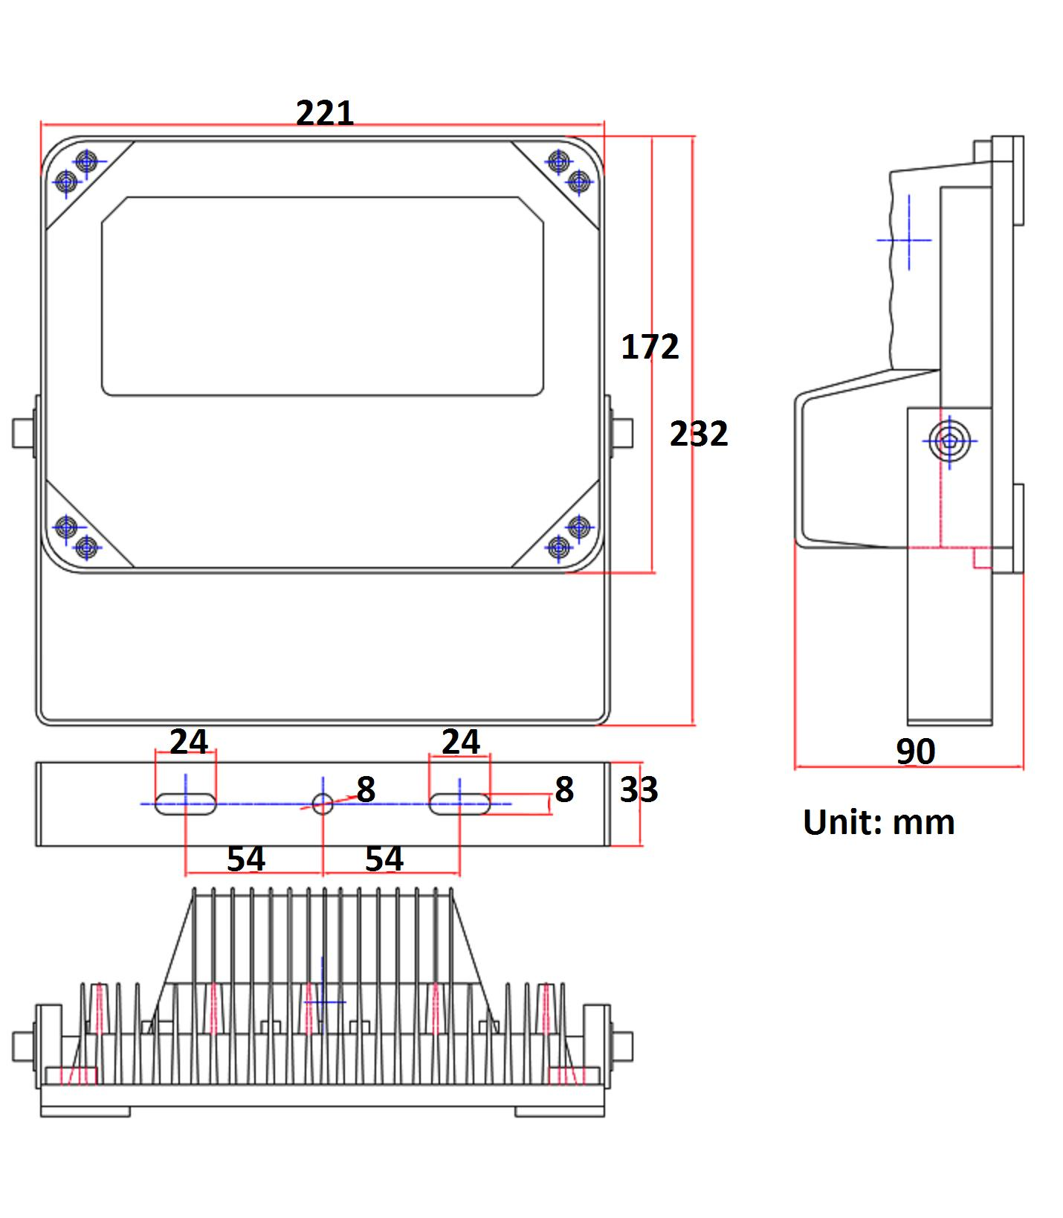
LED type: 12 pieces high power IR LED
Wavelength: 740nm/850nm/940nm
Beam angle: 15 to 120°
Beam distance:150m to 30m(850nm)
Bracket: wall mount bracket
Working voltage: 85-265V AC/12-24V DC/24V AC
Cable: 1.3m(85-265V AC)/0.45m(12-24V DC/24V AC)
Power consumption: 28W(850nm)
Day/night switch: automatic
Working temperatures: -30 to 50°C
Protection level: IP66
Color: beige/black
Panel: tempered glass panel+IR passing plastic
Housing: aluminum die-casting housing
N.W: 1.7KG
G.W: 2KG
Dimension: 221*172*90mm
Packing dimension: 250*200*120mm
Model for Selection
Model Beam angle IR distance(850nm)
S-SE12-15-IR 15° 150m
S-SE12-30-IR 30° 100m
S-SE12-45-IR 45° 70m
S-SE12-60-IR 60° 50m
S-SE12-90-IR 90° 40m
S-SE12-120-IR 120° 30m
*IR distance is tested by Sony 1/3 CCD Camera.
To achieve the distance needed, please pay attention to your camera specification and lens before purchase. It is normal phenomenon that distance may vary due to different cameras and lens.

