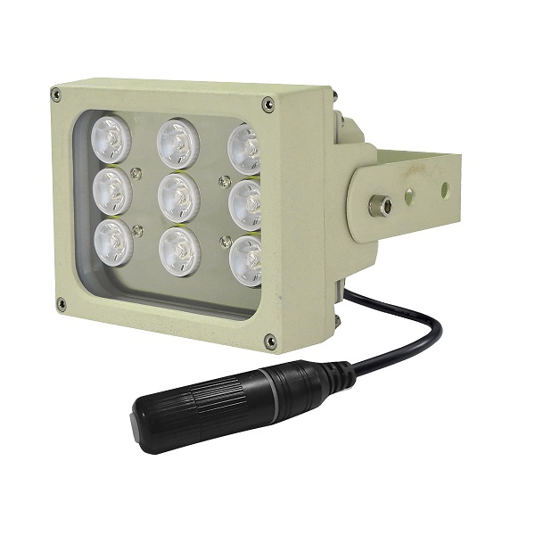
S-S09DP-IR
· Deliver high power infrared light for CCTV & IP camera at night time and
improve performance of camera to get clear pictures.
· PoE (Power over Ethernet) powered.
· 30,000 hours lifetime of LED.
· 3 years warranty.
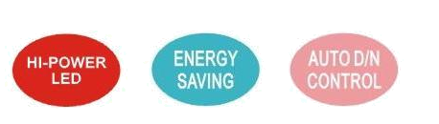
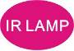
Professional Design
· It's designed to work with network camera via PoE(Power Over Ethernet).
· Two stages of constant current circuit avoid LED away from instantly impulse impact when started.
· Low failure rate of products is guaranteed by the professional in-house optimized independent circuit technology, which has been widely used in our LED illuminators for more than 5 years.
· Wide edge of silica gel circle and water stop line ensure IP66 waterproof and dustproof level.
· Twice direct cooling heat sink processing enable to increase the cooling coefficient and prolong the service life of the product.
· Patent design hexagonal spherical light sensor more accurately responses ambient brightness and
improves accuracy of automatic light control.
· Flexible angle adjustable bracket can extend the illuminance range widely.
· Robust cooling fin design is available the illuminator working at -40℃ to 50℃.
· Super energy saving circuit with low electrical power consumption.
Qualified Material
· Super power dot-matrix IR LED with strong light effect, long service life and low light decline feature.
· High efficient twice optical lens processing achieves 90% of the luminous efficiency.
· The housing adopts high thermal conductivity aluminum to enhance heat dispersion property.
· Stainless steel bracket and screw ensure low maintenance.

Wide Range of Application
· Recommended for security at ports, railway systems, border, prisons, traffic LPR/ANPR, ITS as well as large public places surveillance.

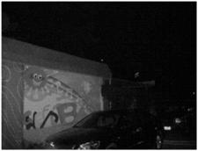
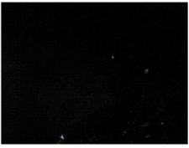
Basic Function Viewing picture at night
•To improve performance of the weak light camera,
thereby enhancing the picture effects at night.
•Conventional night monitoring
•The function of video analysis at night
•Reduce signal noise and other image distortion
•Reduce the network bandwidth requirements
•Energy saving by power factor correction With IR Without IR
•Reduce the equipment cost
•Lower cost of installing and wiring
Picture Product Certificate
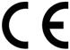



Technical Specification Drawing
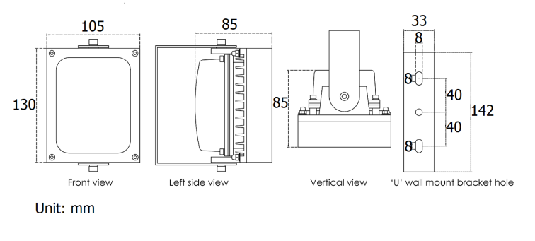
LED type 9pcs 2W dot-matrix IR LED
Wavelength 740nm/850nm/940nm
Input PoE IEEE 802.3at
Power consumption 24W(850nm)
Day and night switch Auto (build in photocell)
Cable IP66 RJ45 jack and Cat.5e 50cm
Mounting Wall mounting “U” bracket
Temperature -40℃ to 50℃
Grade of protection IP66
Color Beige
Housing Aluminum
Panel High light transmittance toughened glass
Net weight 1.4kg
Gross weight 1.7kg
Dimension 130*105*85mm
Packing dimension 190*180*135mm

Model for selection
Model Beam angle IR distance(850nm)
S-S09DP-15-IR 15° 120m*
S-S09DP-30-IR 30° 80m*
S-S09DP-45-IR 45° 55m*
S-S09DP-60-IR 60° 40m*
S-S09DP-90-IR 90° 30m*
S-S09DP-120-IR 120° 20m*
*IR distance is tested by Sony 1/3” CCD Camera.
To achieve the distance needed, please pay attention to your camera specification and lens before purchase. It is normal phenomenon that distance may vary due to different cameras and lens.

