S-H301-IR-YK
• The H series high power IR illuminator is a top quality LED light
source of night illumination with the longest service life.
• Deliver high power infrared light for CCTV & IP camera at night time and
improve performance of camera to get clear pictures.
• Remote control led brightness and sensitivity of light sensor.
• 50,000 hours lifetime of LED.
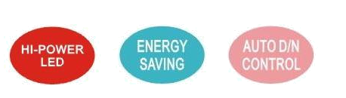
• 3/5 years warranty.
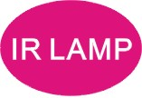
Professional Design
• Two stages of constant current circuit avoid LED away from instantly impulse impact when started.
• 50% design margin and accurate constant current circuit drive not only develop excellent performance of LED but maintain whole product a super long life of 10 years.
• Low failure rate of products is guaranteed by the professional in-house optimized independent circuit technology, which has been widely used in the illuminators for more than 5 years.
• Wide edge of silica gel circle and water stop line ensure IP66 waterproof and dustproof level.
• Twice direct cooling heat sink processing enable to increase the cooling coefficient and prolong the service life of the product.
• Patent design hexagonal spherical light sensor more accurately responses ambient brightness and
improves accuracy of automatic light control.
• Flexible angle-adjustable bracket can extend the illuminance range widely.
• Robust cooling fin design is available the illuminator working at -40℃ to 50℃.
• Super energy saving circuit with low electrical power consumption.
Qualified Material
• Super power dot-matrix IR LED with strong light effect, long service life and low light decline feature.
• High efficient twice optical lens processing achieves 90% of the luminous efficiency.
• The housing adopts high thermal conductivity aluminum to enhance heat dispersion property.
• Stainless steel bracket and screw ensure low maintenance.
Wide Range of Application
• Recommended for security at ports, railway systems, border, prisons, traffic LPR/ANPR, ITS as well as
large public places surveillance.
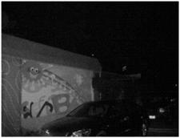
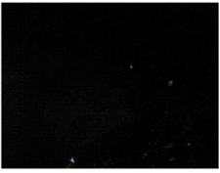
Basic Function Viewing Picture at Night
•To improve performance of the weak light camera
and enhancing the picture effects at night
•Conventional night monitoring
•The function of video analysis at night
•Reduce signal noise and other image distortion
•Reduce the network bandwidth requirements
•Energy saving by power factor correction With IR Without IR
•Reduce the equipment cost
•Lower cost of installing and wiring
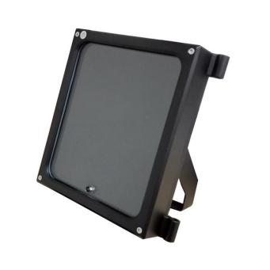
Picture Product Certificate
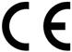



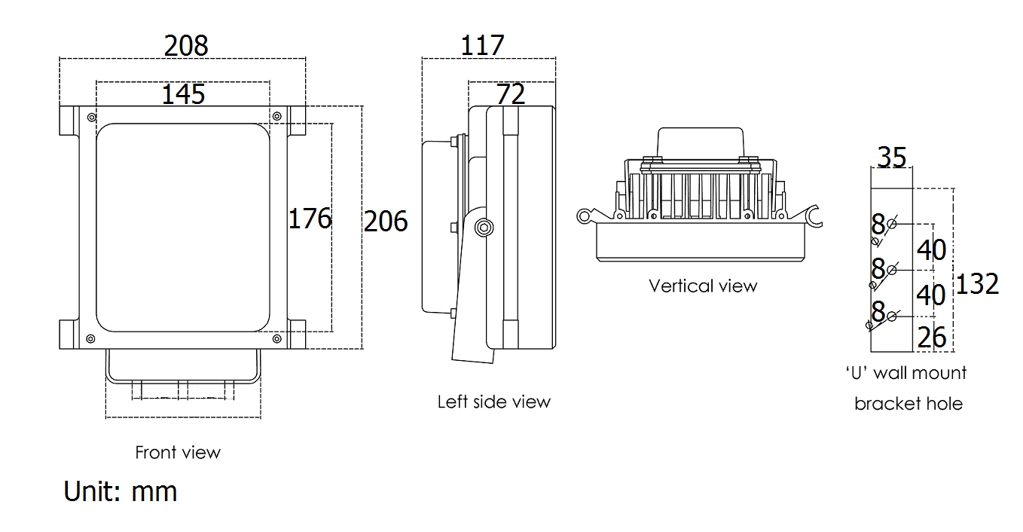
Technical Specification Drawing
LED type 30pcs 2W dot-matrix IR LED
Wavelength 740nm/850nm/940nm
Voltage AC85-265V/DC12V/AC24V
Power consumption 37W (850nm)/adjustable
Day and night switch Auto/adjustable
Cable length 1.3meter
Mounting Wall mounting “U” bracket
Temperature -40℃ to 50℃
Grade of protection IP66
Color Black
Housing Aluminium
Panel High light transmittance toughened glass
Net weight 3.3kg
Gross weight 3.75kg
Dimension 208*206*117mm
Packing dimension 300*260*200mm

Model for selection Remote Control
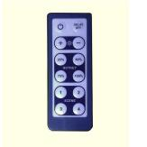
Model Beam angle IR distance(Max.)
S-H301E-10-IR-YK 10° 260m*
S-H301-15-IR-YK 15° 200m*
S-H301-30-IR-YK 30° 150m*
· Adjustable of light sensitive to 25%, 50%, 75% and 100%.
· Adjustable of power from 10%-100%.
· 0-8m remote control distance.
S-H301-45-IR-YK 45° 90m*
S-H301-60-IR-YK 60° 70m*
S-H301-90-IR-YK 90° 60m*
S-H301-120-IR-YK 120° 50m*

*IR distance is tested by Sony 1/3 CCD Camera.
To achieve the distance needed, please pay attention to your camera specification and lens before purchase. It is normal phenomenon that distance may vary due to different cameras and lens.

