Phone Monitoring User Manual
This manual is intended for phone monitoring of Android, blackberry, windows mobile, iphone and symbian mobiles.
To get the right client side software:
From the CD-ROM provided by our company > Chinese>Tools> Phone monitoring or from our technical support department, the client side software and their corresponding phone model are as follows:
MEYE_SB_S60_3rd.sisx：Symbian S60 v3 operating systems
MEYE_SB_S60_5rd.sisx：Symbian S60 v5 operating systems
MEYE_WM.cab：windows mobile operating systems
MEYE_Android.apk：android operating systems
MEYE_RIM.rar: BlackBerry operating systems
Note：Iphone users can search vMEye from appstore and install it on line.

Current programs for phone monitoring have the following functions:
- View real-time video；
- Control PTZ ( the cameras should be controllable speed dome)
Reference for settings of DVRs supporting phone monitoring
Resolution: CIF or QCIF；
Frame rate: 5-10 fps；
Code stream type: Limited
Bit rate：64-256Kb/S
Note: Settings can be adjusted according to mobile performance and network status. Better performance of mobile and network status bring better display effects. Frame rate can be reduced properly to ensure fluency if the network situation is not good.

1. Phone monitoring instructions for Android

1. System Requirements
Android 1.5v or above
Mobile: HTC G1，HTC Magic，HTC Hero，HTC G5.

2. Installation and Operation Instructions

1）Copy the installation package Vmeye.apk to your Android phone or search Vmeye on Google store for online installation, shown as below:
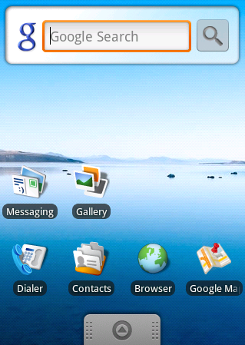

2) Find the corresponding .apk in specified directory and click the application to Install it(（Normally your phone would contain apk installer, if not ,you will need to download a apk install software to recognize apk package.）Once installation is complete, the program icon will show up :
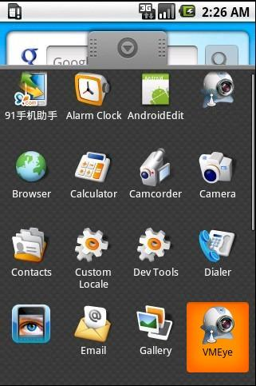

3）Click the corresponding program icon and the initial screen would be as follows:
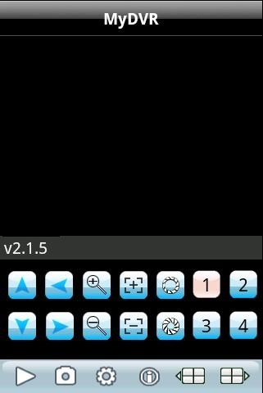
Buttons and their functions：
Button | Function | Descriptions
 | Play | Start playing video
 | Snapshot | Capture current image( Pictures captured will be saved to default picture directory of your phone)
 | Settings | Configure the IP address, dynamic domain, port number, user name, password and device name of DVR
 | Last Group | Select last channel group
 | Next Group | Select the next channel group
 | About | Software information
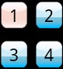 | Select Channel | Choose the channel video to play. Can realize 8 channel, 16 channel switching with “Next Group” button
 | PTZ Control | Move up, down, left, right
 | Zoom | Far/Near
 | Focus | Focus control
 | Aperture | Aperture control

4）For first-time users, or you want to modify configurations, please click [Settings] to enter setting interface:

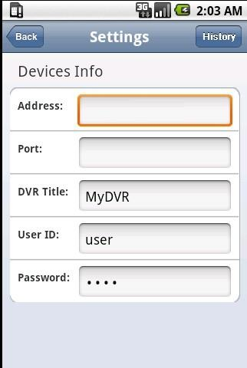
Note：
Server Address： IP Address or dynamic domain of DVR
Server Port： The port you set on your DVR
Device Name： Device name for distinguishing different devices
User Name： The user name should be the same with IE setting
Password： The password should be the same the IE setting
：Reverse back
：Enter historical page

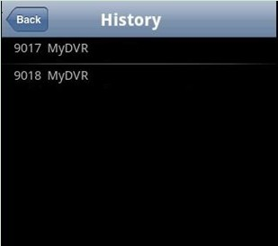
Click the historical record to display the record
Delete historical record
Select the device record to be deleted and long press it to pop up a dialog box. Select Delete to delete the record.
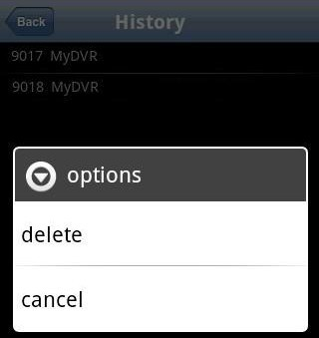

5）Video Display Mode
Normal screen mode and full screen mode, normal screen mode is shown as follows:
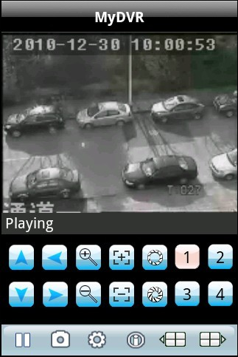
When you put your phone horizontally, it will play in full screen automatically.
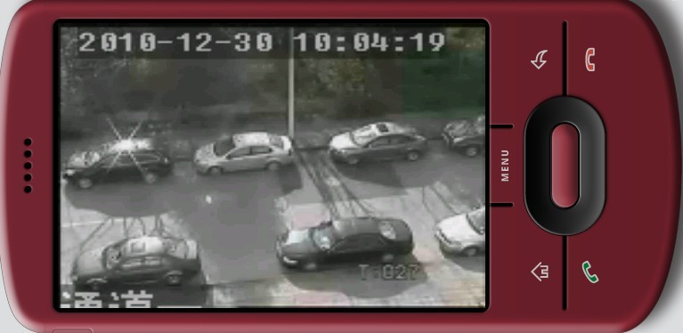

7）Channel Switching
Select the corresponding channel number to display its video. The program will display 1~4 channel by default and click Next Group button to display 5~8, 8~12 and 12~16 channel.

2. Phone monitoring instructions for Blackberry

1. System Requirement
Blackberry 4.6 v or above, resolution of your phone screen should be 480*360 or 480*320：8900、9000、9700、9630 etc. Blackberry should be updated to certain version to ensure a good viewing effect.
8900/9000 needs to be updated to 5.0.0.90 system
9700 needs to be updated to 5.0.0.714 or 5.0.0.344

2. Installation and Operation Instructions

1）Install vMEye.cod and vMEye.alx package to your blackberry through desktop manager：
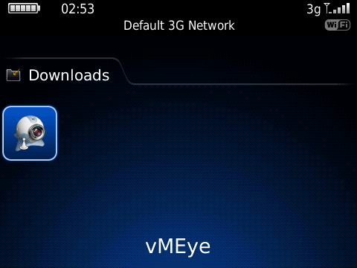

2）Click Options on your phone desktop :
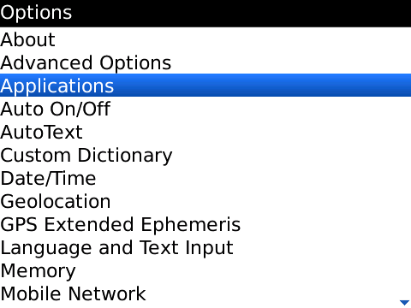

3) Click Applications to find vMEye and click it. Select Edit Permissions and set Permissions as allow. If part of permissions cannot be set ,just skip them and save the settings.

4）Click the vMEye program icon and the initial screen would be as follows：
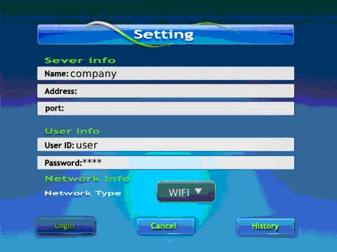
Note：
Server Address： IP Address or dynamic domain of DVR
Server Port： The port you set on your DVR
Device Name： Device name for distinguishing different devices
User Name： The user name should be the same with IE setting
Password： The password should be the same the IE setting
Network Type: Select the network type you want

Buttons and Functions:
Button | Function | Descriptions
 | Login | Enter player interface and start playing
 | Cancel | Exit
 | History | Enter historical pages

5) Login and player interface will be shown as follows:
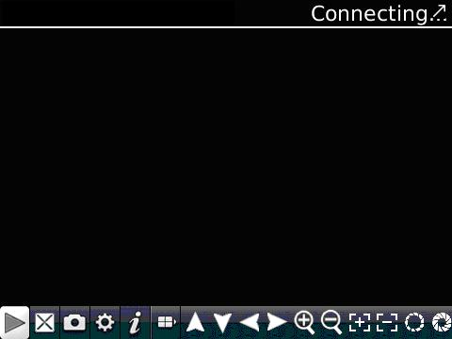
Buttons and their functions:
Button | Function | Descriptions
 | Play | Start playing video
 | Full Screen | Full screen display
 | Snapshot | Capture current image( Pictures captured will be saved to default picture directory of your phone)
 | Settings | Configure the IP address, dynamic domain, port number, user name, password and device name of DVR
 | Next Group | Select the next channel group
 | About | Software information
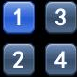 | Select Channel | Choose the channel video to play.
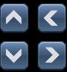 | PTZ Control | Move up, down, left, right
 | Zoom | Far/Near
 | Focus | Focus control
 | Focus control | Aperture control

6) Click Cancel to quit the program:
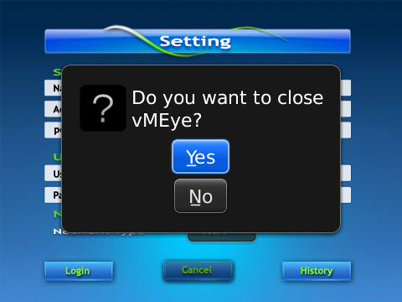

7) Click History to get historical records：
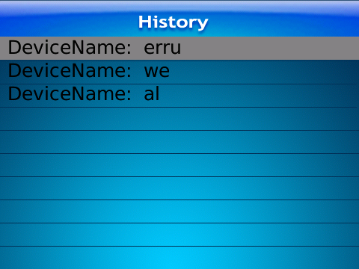

8) Click Menu to popup menu:

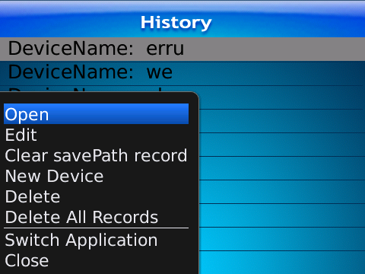

Menu and functions：
Button | Function | Description
open | Play | Star playing
edit | Edit | Edit records
Clear savePath record | Clear | Clear save path(save path for snapshot pictures)
New Device | New | Create a new record
Delete | Delete | Delete records
Delete All Records | Delete All | Delete all records
Switch Application | Switch | Switch to other application program
Close | Close | Close the program

6）Video Display Mode
Normal screen mode and full screen mode, normal screen mode is shown as follows:
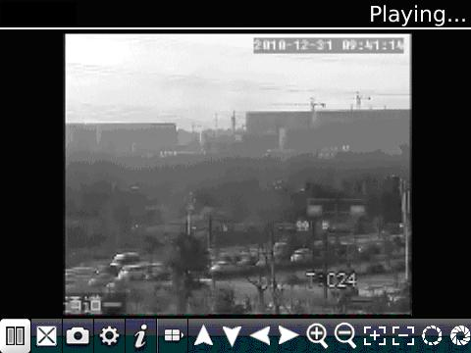
Full screen：
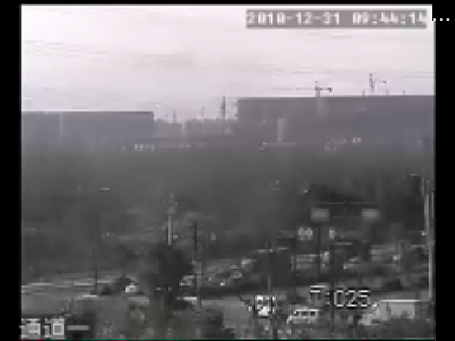

3. Phone monitoring instructions for Symbian

1. System Requirements
symbain 9.1 v or above: symbian v3 and v5, including Nokia 6120c, e71,5800 etc.
Resolution for version 3: 240*320,320*240, version 5: 360*640,640*360

2. Installation and Operation Instructions

1）Download installation package (sisx) to your phone and install it .

2）The program icon will show up once the installation is complete. Find vmeye in the right directory:
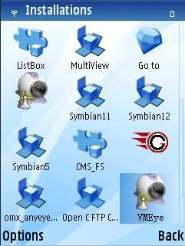

3）Click vmeye, initial interface is as follows:
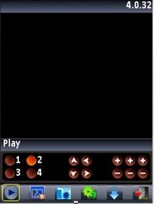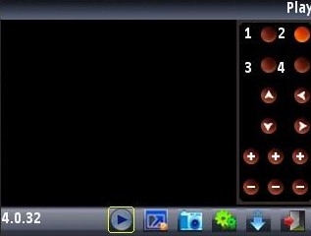
Portrait mode Landscape mode

Buttons and functions：
Button | Function | Description
 | Play | Start Playing
 | Snapshot | Capture current image( Pictures captured will be saved to default picture directory of your phone)
 | Settings | Configure the IP address, dynamic domain, port number, user name, password and device name of DVR
 | Next Group | Select the next group channel
 | Exit | Quit the program
 | Full Screen | View in full screen
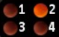 | Selecting Channel | Choose the channel video to play. Can realize 8 channel, 16 channel switching with “Next Group” button
 | PTZ Control | Move up, down, left, right
 | Zoom, Focus，Aperture | Zoom in/out, focusing, aperture controlling. The above hint bar will show the function of selected button.

4）For first-time users, or you want to modify configurations, please click [Settings] to enter setting interface:
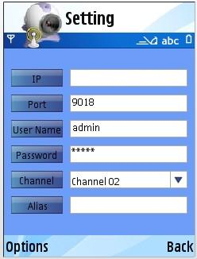

Note：
Server Address： IP Address or dynamic domain of DVR
Server Port： The port you set on your DVR
Device Name： Device name for distinguishing different devices
User Name： The user name should be the same with IE setting
Password： The password should be the same the IE setting
Alias: Alias will be shown on play window
Open Options to enter History list, or click Play to back to video playing interface and the current settings would be saved. Click Back directly to back to previous playing interface will not save the current settings.
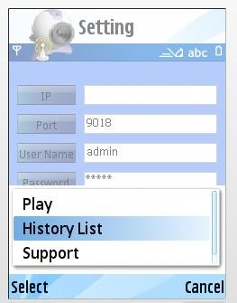
You can select or cancel history list.
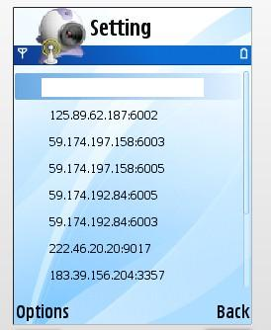
Select one record in history list and open Options to click OK/PLAY to view this record.

Delete History Record
Select the record to be deleted and open Options to click Delete to delete the record.

5）Video Display Mode
Normal screen mode and full screen mode, normal screen mode is shown as follows:
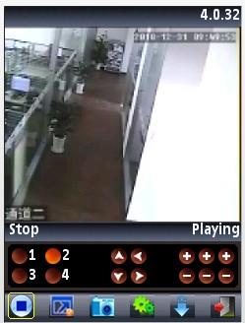 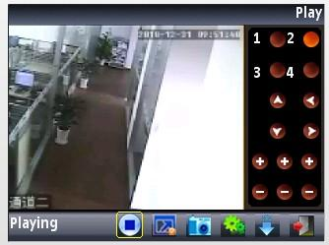 Normal Screen Normal Screen
When you put your phone horizontally, it will play in full screen automatically.
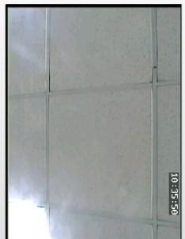

6）Channel Switching
Select the corresponding channel number to display its video. The program will display 1~4 channel by default and click Next Group button to display 5~8, 8~12 and 12~16 channel.

4. Phone Monitoring of Windows mobile

1. System Requirements
Windows mobile 2003v or above. Only touch-screen is supported at present.

2. Installation and Operation Instructions

1）Copy VMeyesetup.cab to windows mobile phone.
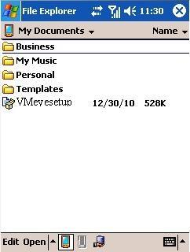

2) Find VMeyesetup.cab in the specified directory and double click to install it. The program icon will show up once the installation is complete.
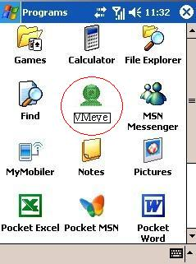

3）Click the corresponding icon and initial interface will be shown as follows:
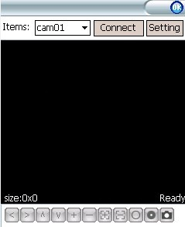
Buttons and functions：
Button | Function | Description
 | Connect and play | Connect to device and start playing
 | Setting | Configure the IP Address, Dynamic Domain, Port number, User Name, Password and Alias of DVR.
 | Disconnect | Stop playing video.
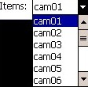 | Selecting Channel | Select the channel video to play.
 | PTZ Control | Move up, down, left, right
 | Zoom | Zoom in/out
 | Focus | Focus Control
 | Aperture | Aperture Control
 | Snapshot | Capture current image( Pictures captured will be saved to default picture directory of your phone)
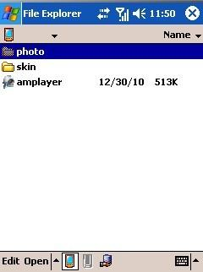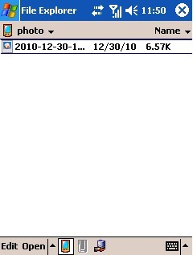

4）For first-time users, or you want to modify configurations, please click to enter setting interface:
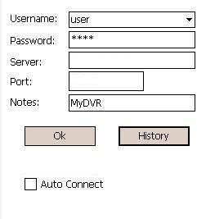

Note：
Server Address： IP Address or dynamic domain of DVR
Server Port： The port you set on your DVR
Device Name： Device name for distinguishing different devices
User Name： The user name should be the same with IE setting
Password： The password should be the same the IE setting

Click button to enter history record page.
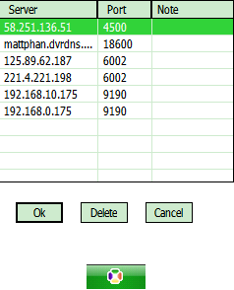
Select the record to be delete and click Delete to delete it.
Select one record and click [OK] to return to setting interface.
Click [OK] again to enter connection interface. Once the connection is successful, it will start playing.
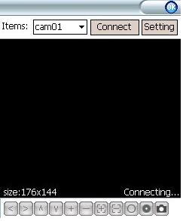

5）Video Display Mode
Normal screen and full screen can be switched. Click to stop view in normal screen mode. Click the picture to switch to full screen and click again to return to normal screen.
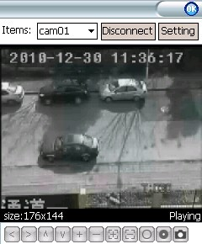
Normal Screen Mode Full Screen Mode

6）Channel Switching
Clickbutton and select corresponding channel number. The program will automatically play the video.

5. Phone Monitoring for iPhone

1. System Requirements
iOS 3.0 or above.Mobile phone includes iPhone,iPod touch etc.

2. Installation and Operation Instructions

1）Run App Store and switch to search tag page. Enter vMEye and find the corresponding installation package. Click to install it and the program icon will be shown as follows:
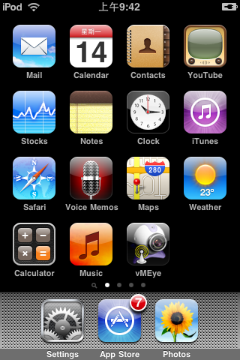

2）Click vMEye icon and initial interface is shown as below:
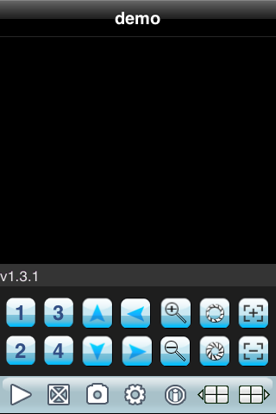
Buttons and functions:
Button | Function | Description
 | Play | Connect device and start playing
 | Snapshot | Capture current image( Pictures captured will be saved to default picture directory of your phone)
 | Setting | Configure the IP Address, Dynamic Domain, Port number, User Name, Password and Alias of DVR.
 | Last Group | Select the last group of channels
 | Next Group | Select the next group channel
 | About | System information
 | Selecting Channel | Choose the channel video to play. Can realize 8 channel, 16 channel switching with “Next Group” button
 | PTZ Control | Move up, down, left, right
 | Zoom | Zoom in/out
 | Focus | Focus control
 | Aperture | Aperture control

3）For first-time users, or you want to modify configurations, please click Setting to enter setting interface:

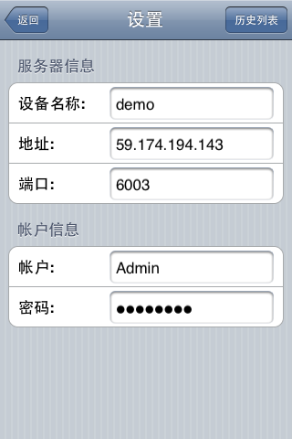
Note：
Server Address： IP Address or dynamic domain of DVR
Server Port： The port you set on your DVR
Device Alias： Device alias for distinguishing different devices
User Name： The user name should be the same with IE setting
Password： The password should be the same the IE setting
：Return button
：Enter history list
Select one record in history list and click to view the record.

Click Edit button and click the red delete button to delete the record.：
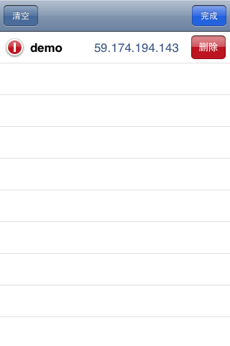

Video Display Mode
Normal screen mode and full screen mode can be selected. When you put your phone horizontally, it will play in full screen automatically.
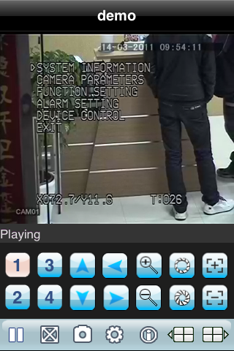

5）Channel Switching
Select the corresponding channel number to display its video. The program will display 1~4 channel by default and click Next Group button to display 5~8, 8~12 and 12~16 channel.

