EC DECLARATION OF CONFORMITY

We CBC (Deutschland) GmbH
Hansaallee 191
40549 Düsseldorf
Germany

declare under our sole responsibility that the product

Name: CTR-4024

Description: Time Lapse Video Cassette Recorder

Referred to in this declaration conforms with the following standards or directives:

Directive : 89/336/EEC and 73/23/EEC modified by laws 92/31/EEC and 93/68/EEC

EN55022 :1994/A2 :1997, EN61000-3-2/3/A2 :1998, EN50130-4/1998, EN60065/1993

We will keep on file for review the required documentation.

Date: 25.02.2002
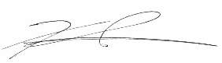
Signature:

Name: Koji Ikeda

Position: General Manager

