How To Use Rs232 to Update F/W
Step 1. Please Download a software Tera Term and install this software from this website http://ttssh2.sourceforge.jp/index.html.en
Step 2. Open the Tera Term program. Make sure that your serial settings (Setup > Serial port) are 115200 baud rate/ 8 bits/ no parity/ 1 stop bit/ no flow control. The Port can be set to COM1 or COM2 depending on your connection.
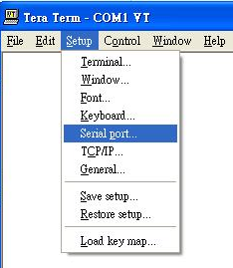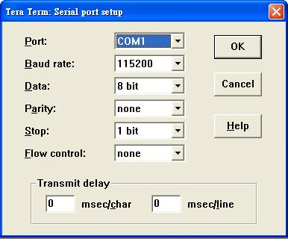
Step3. Connect the B1080PX and PC with RS232 cable.
NOTE: The B1080PX must be powered off before connecting to PC
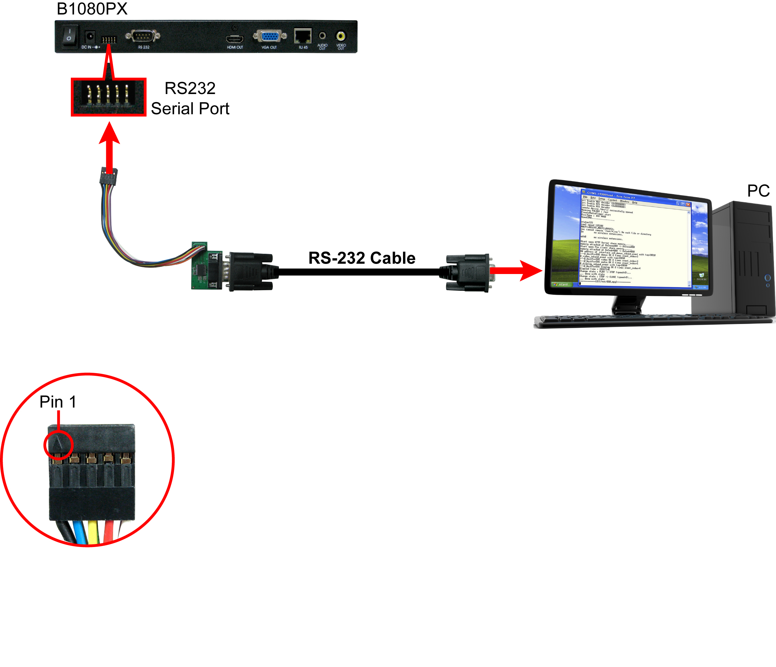
Note the direction: There is an identifying mark close to Pin 1
Step4. Press and hold the “0” key and turn on the B1080PX. You can release the “0” key until you see the screen shown below (YAMON> 0000000000000000).
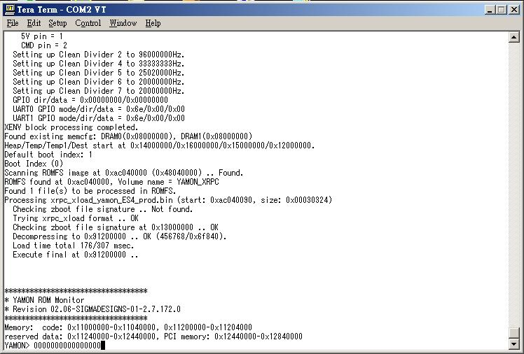

Step5. Press the Backspace key to delete text (0000000000000000).

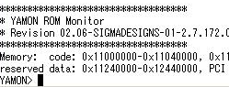
Step6 Enter the command “load uu 0xb0100000”
YAMON> load uu 0xb0100000



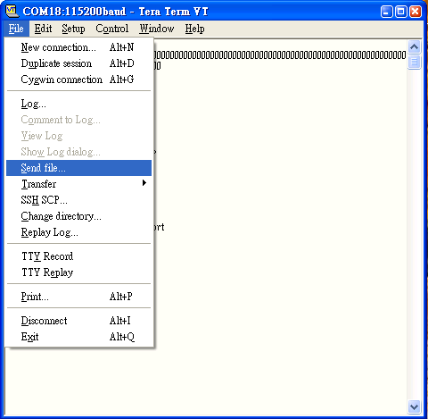

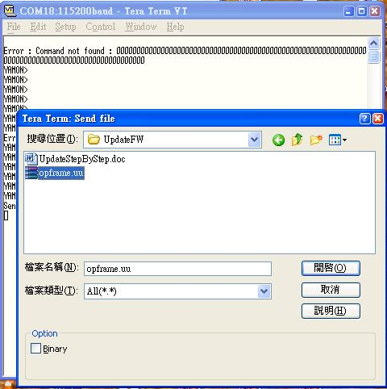
Please Select “PX-Kernel.uu”

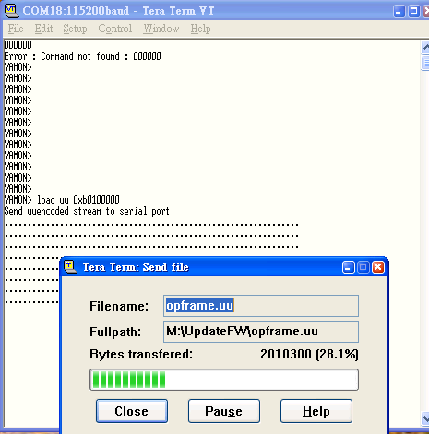
PX-Kernel.uu

Step7 Enter the command “pflash write 0x80000 0xb0100000 <received size>”
YAMON> pflash write 0x80000 0xb0100000 5197824

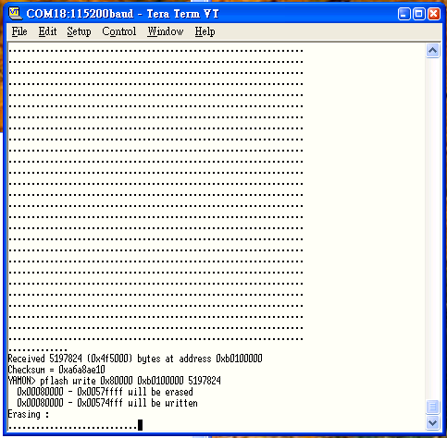

Step8 Enter the command “xrpc 0xac080090”
YAMON> xrpc 0xac080090

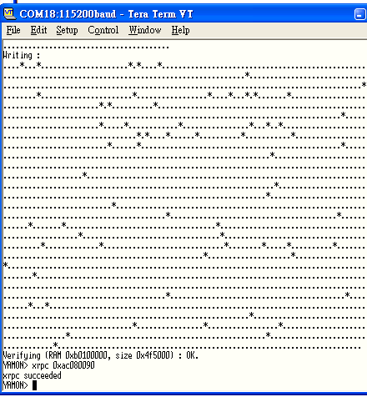

Step9 Enter the command “load zbf 0xb3000000”
YAMON>load zbf 0xb3000000
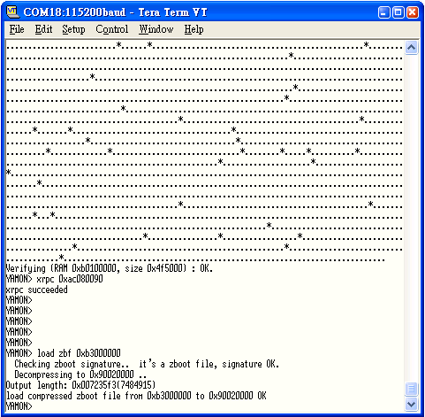
Step10 Enter the command “setxenv -b z.default_boot 1”
YAMON>setxenv -b z.default_boot 1
Step11 Enter the command “go”
YAMON>go

Then Switch the Tera term BoudRate to 19200
